**git version 2.35.1.windows.2**

* Git is a Distributed version control system(VCS) or Source Code Management(SCM) Tool which keeps track of changes especially text changes n which can be used to manage code.

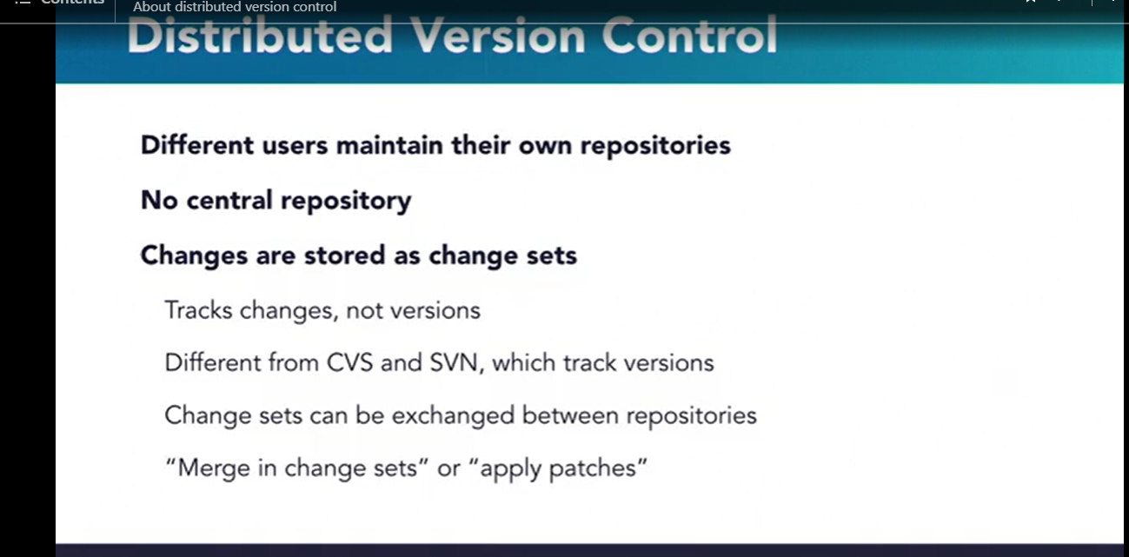

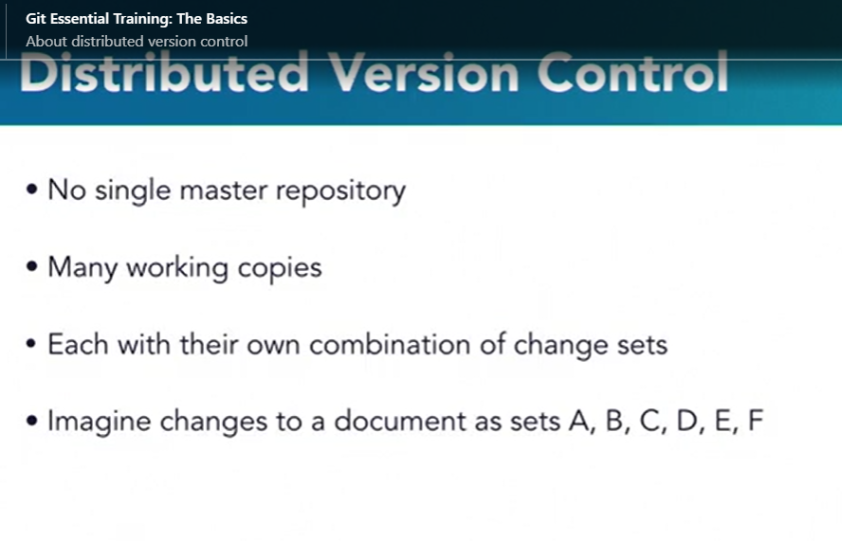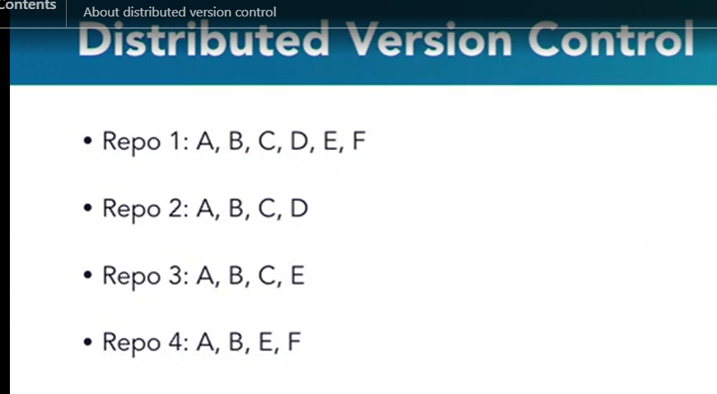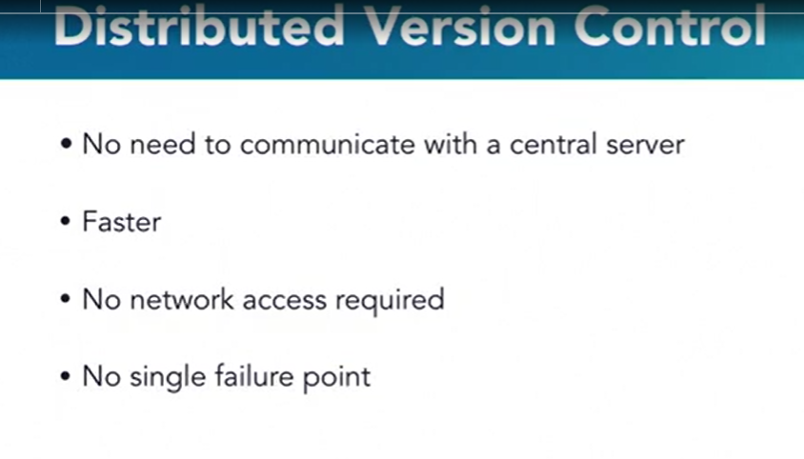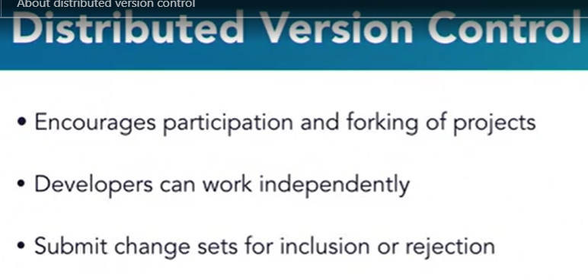

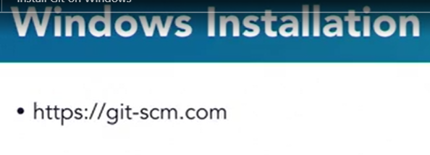

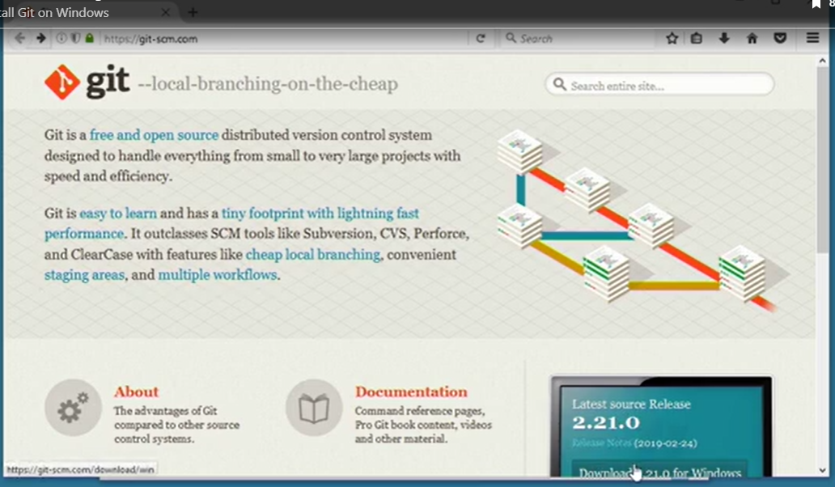

Install the git with default provided selections,once complete check the git installation via command prompt by typing git –version in command prompt Or in git bash by typing git –version or git version.

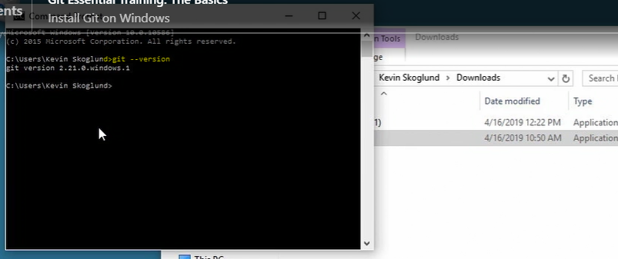

Note:To increase the font size of word in git bash press ctrl and +

Similarly to reduce the font size of word in git bash press ctrl and –



Git configuration can be applied at different levels:

1)System:these configurations can be applied to all system users.

Command: git config --system

2)User or global:these configurations can be applied to specific user.

Command: git config --global

3)Project:these configurations can be applied to specific projects .git folder.

Command:git config



Git allows its commands to be auto populated if we need to do that.Windows supports auto completion by default but mac n linux needs to perform some extra activivties to allow git to auto complete the command.We use tab keyboard button in all os to auto complete the command.

Let say we want to write git config command but we forgot the statement ( like whether it is config or configs or configuration or configurations ) then what we can do is we can write git c n then press tab button two times(to see the available command options) so it will show available commands starting from c.if you type git co n then press tab button twice then it will show available commands starting from co i.e commit n config.if you type git con n then press tab key once(since only one command will be there with con). it will auto complete the git config

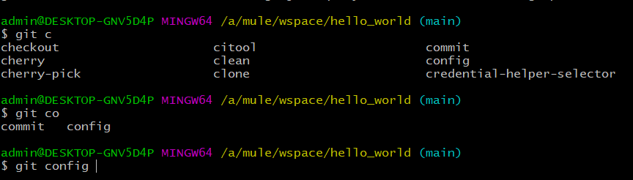 GIT THREE STAGE ARCHITECTURE OR How Git Works?

<https://youtu.be/Cdg2FGDMglk>

Git works in three stage Architecture which involves:-

1)Current Working Directory:-

2)Staging Directory

3)Git Repository or Git Directory:-it is a .git hidden folder created in a Current Working Directory which you want to store in git. In .git folder,we have all stored info about the version files n all.

.git folder is a hidden folder created in your current working directory which is hidden by default.

To unhide/see those .git folder in current working directory, perform following step:

* Go to current working directory path, click on view menu->in shw/hide panel,u will get file name extensions (to view the file names with extension like surya.txt) and hidden items checkbox,check them to allow to see .git folder + files with their extensions.

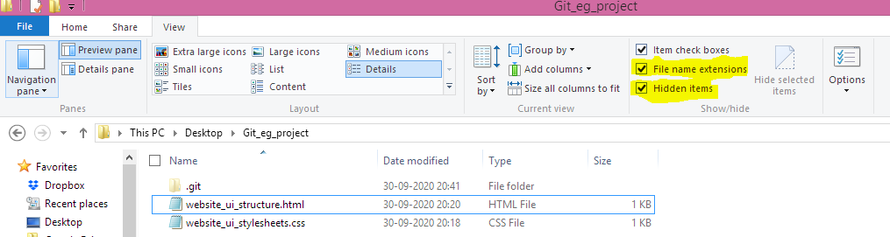

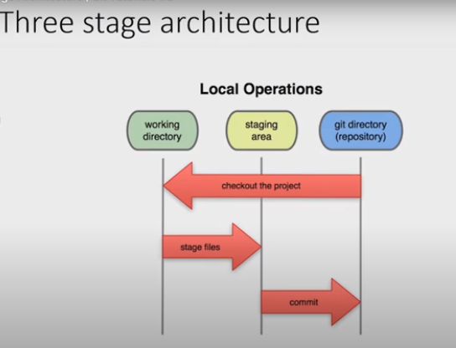

First of all, let us have a look at a two stage architecture Version Control System.

In a two stage Version Control System, we work on our working directory, commit some changes and then push to the repository. Then again, we can pull the changes from the repository (changes which might have done by our colleagues), commit some changes, and again push back the files to the repository.

Till now, it seems very good, but now imagine a situation, when you are working on a project consisting of say 4 files. Now, you have finished working on 2 files, but in other 2 files, you have encountered some bug. In such situation, if you commit changes to the repository, then the other two files containing bug will also be committed to the repository. This is a serious problem!

But git solves this problem by introducing a middle stage called “staging area” in this architecture. Let us have a look at three stage architecture now.

Thus, git allows us to first push our files to staging area, and then we can commit those staged files. Continuing our above example, we can only push those two bug-free complete files to staging area and then further commit our changes. The other two files in progress can remain in our working directory. They can be modified later and committed when you need to. Another important advantage of staging area is that files from staging area can again be pulled to our working directory, if we feel they need some more changes before committing them.

**It is to be noted that it is not compulsory in git to first push the files to staging area. The changes can even be directly committed, but it is always a good practice to first stage our files.**

Tracking first GIT Project:-

Video URL:-https://youtu.be/-e0RtzuNgS4

Let say,we have one project which we need to store with git technology for version control .

Path:-C:\Users\suryakant\Desktop\Git_eg_project

Assumption:-assumption we have made is like,there is no already existing .git repository created for Users folder,suryakant folder,Desktop folder

Steps we will follow is like:-

* Open windows path C:\Users\suryakant\Desktop\Git_eg_project

When you will go into the git_eg_project right click->open in git bash(to open git in that directory)

Git Three Stage Architecturer:

Git used to track the changes,so changes has to be gone thru from 3 different stages:

1)Present Working Directory:The changes are initiated from this stage where changes are actually start.

2)Staging Area:once we done the changes in present working directory they need to be forwarded to staging area this we can do by adding the changes from present working directory to staging area.use this command

git add .

. adds each changes in staging area.to add particular change let say we done the changes in first.text in pwd if we want we can add only changes done to first.txt to staging area by writing below command

Git add first.txt

3)Git Repositories:once we add the changes to staging area ,final stage is commiting it to repository.that we can do by following command

Git commit -m “commit_msg”

Where -m stands for message

To get out of any git command n coming back to git console window press q like below:

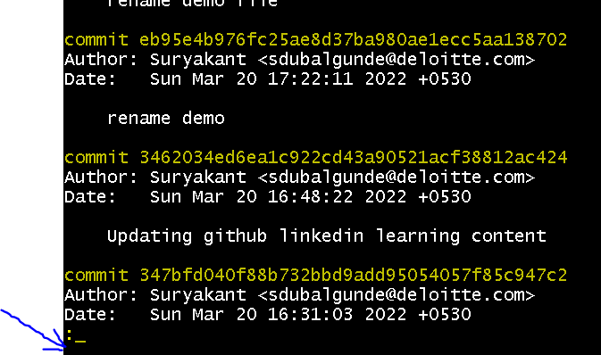

After pressing q u will get git prompt again like below

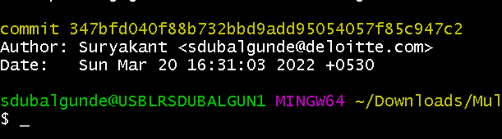

GIT/GITHUB:-

WHAT IS N WHY needed?

-GIT Is a VCS(VERSION Control System) or SCM(Source Code Mgmt Tool)

-VCS is used for controlling the version of any system like file system.

-for eg:-if we create suryakant_resume.docx which contains the skills A,B.By some time later in period of time he modifies n updates the suryakant_resume.docx with skills contains B,C,D.

If after some time he needs the intial file which contains skills A,B in it.He cant retrieve it rght?

+THIS IS POSSIBLE TO RETRIEVE Old docx as well from very intial doc to second doc to latest doc also if we store all docx on Git or VCS systems.

+ if we are storing the files in local ,they can be deleted or can be unable to get back if system gets defected.

+if we are storing the files like suryakant_resume.docx,suryakant_resume_V1.docx,suryakant_resume_V2.docx,..suryakant_resume_Vn.docx

It will lead to consume more space of storage device

-These are some of the problems with versioning of doc,which can be solved by using VCS like GIT etc.

-GITHUB is a one of the hosting server thats hosts git repositary

-other eg:-BITBUCKET,GITLAB etc.

-Git is developed by Linus Torwalds(Developer of Linux Kernal or Linux OS).

Video URL-<https://youtu.be/evknSAkUIvs>

WHY GIT IS AROUND:

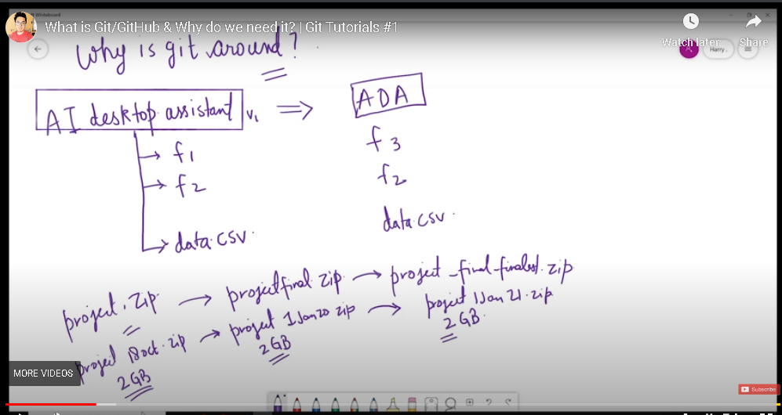

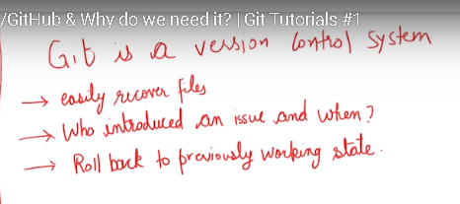

HISTORY OF VCS:-

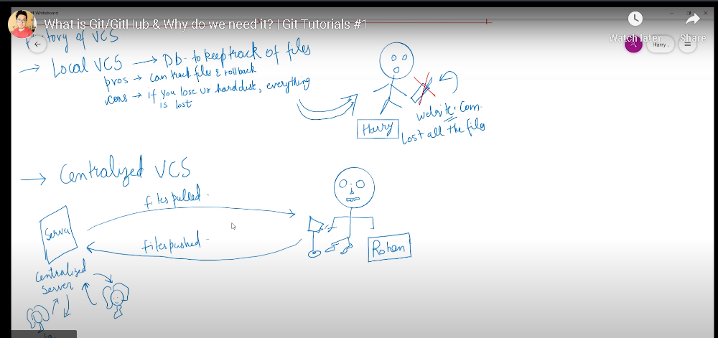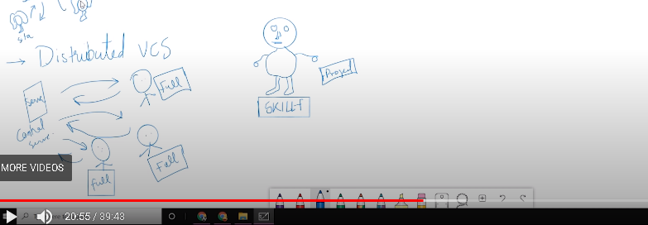

HOW GIT CREATED:-

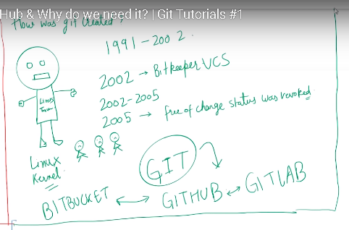

GIT FEATURES:-

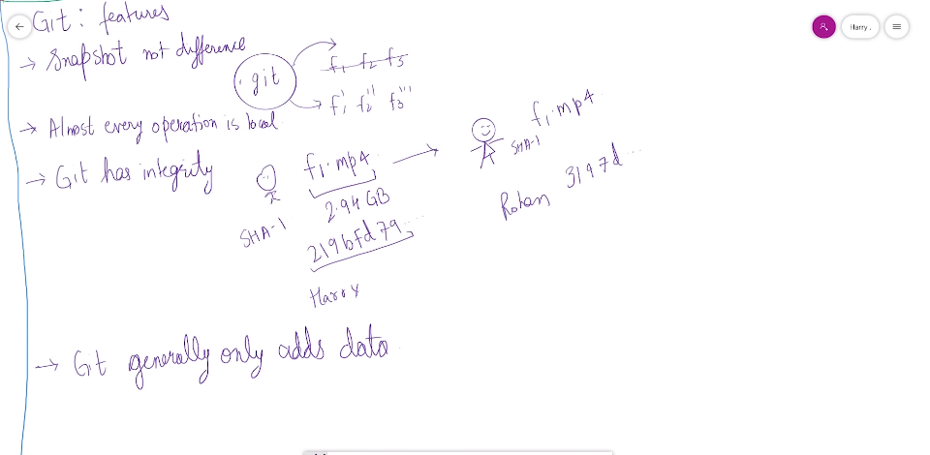

How to install GIT:-

Video url:-<https://youtu.be/qkbK31dMNfM>

1)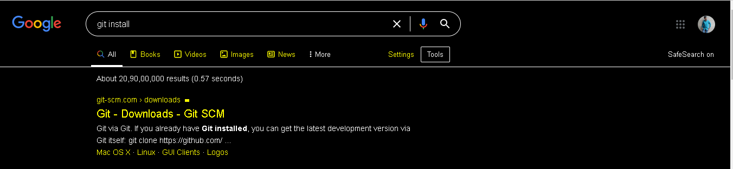

2)

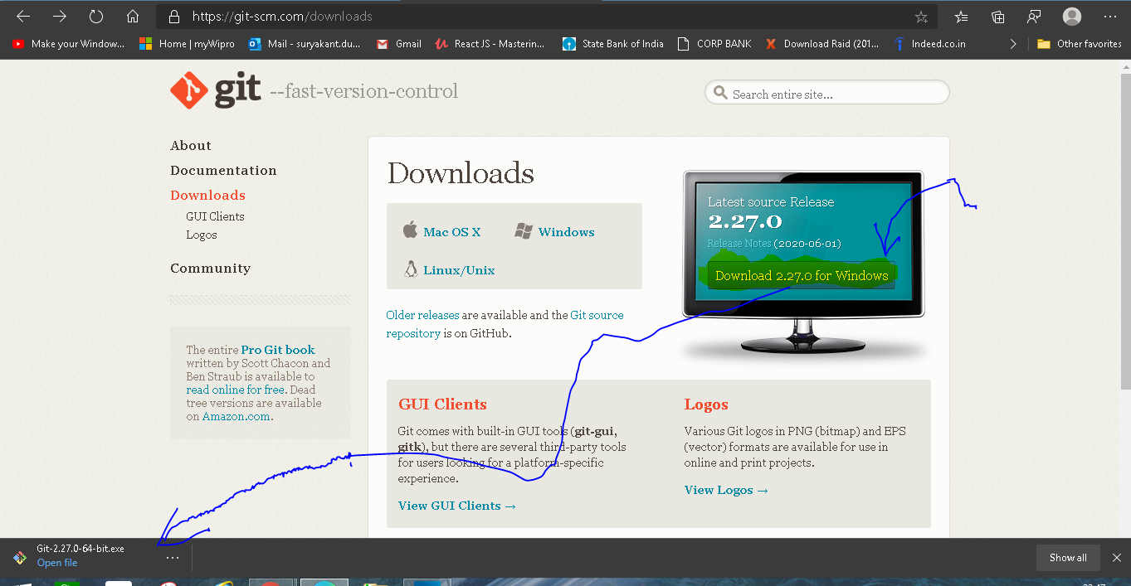

3)OPEN Downloaded file->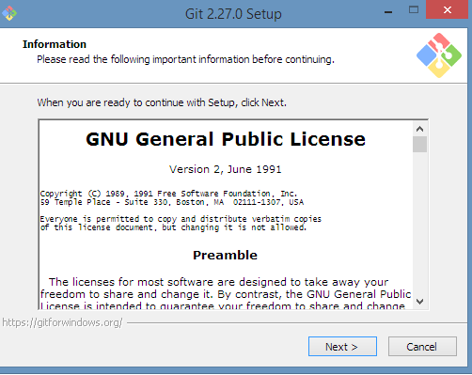

Click next->next->next....->until it gives complete installation window.

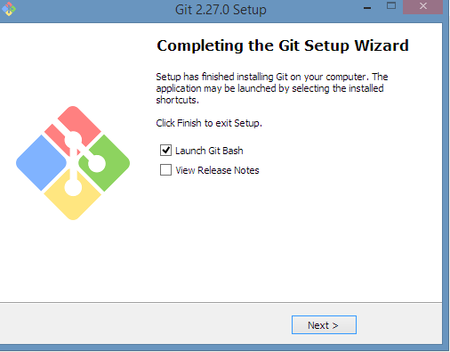

GIT BASH-IT IS A TERMINAL SAME AS WINDOWS CMD OR POWERSHELL,AS LINUX'S terminal,as mac os's terminal.it is command line tool used to fire linux commands and git commands like ls,pwd,git status etc.the look is like a linux

4)to check git installation:-

Using Windows POWERSHELL:-open windows powershell

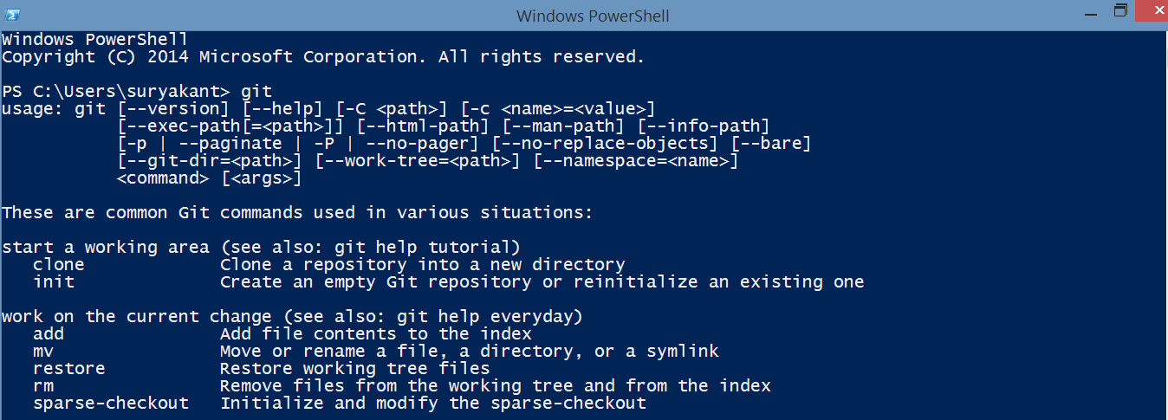

Using Command Prompt:-open Command Prompt

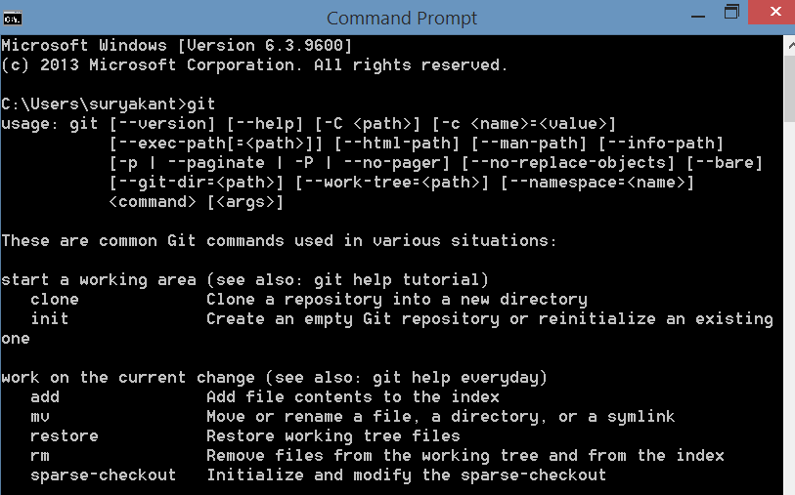

Using GIT BASH:-Open GITBASH

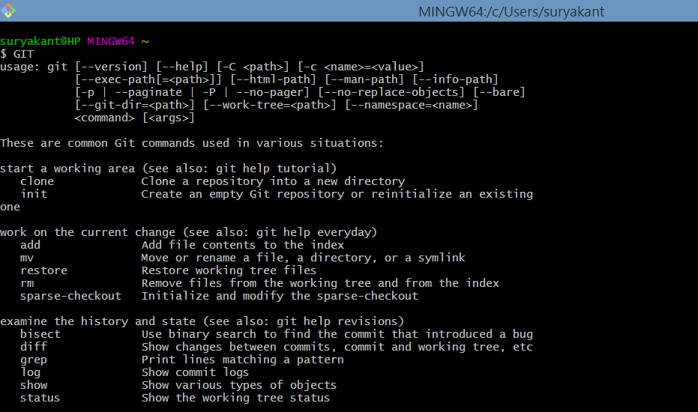

Note:-to increase the font size of letters in GIT BASH press **ctrl and +** and to reduce font size **ctrl and -** symbol.

To check git version in GIT bash OR WINDOWS POWERSHELL: **git --version**

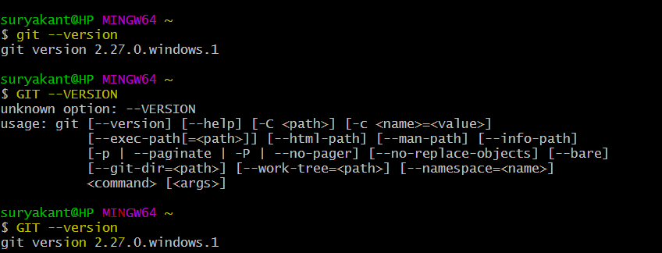

Note:-in commands git can be capital GIT But actual commands like --version etc. should be as mentioned only with correct case and spelling.

Wrong command:- GIT --VERSION

Right command:- GIT --version or git --version

GIT INSTALLATION COMES WITH

* GIT BASH-COMMAND LINE TOOL FOR ACCESSING GIT FUNCTIONALITIES
* GIT GUI-GUI TOOL FOR ACCESSING GIT FUNCTIONALITIES
* GIT CMD-CMD TOOL

Git can be used not only with commands but also with GUI:-You can perform following commands

Git Commands to run on git bash:

* git --version:-tells you the git version which is installed on your system.



* pwd:gives present working directory name.



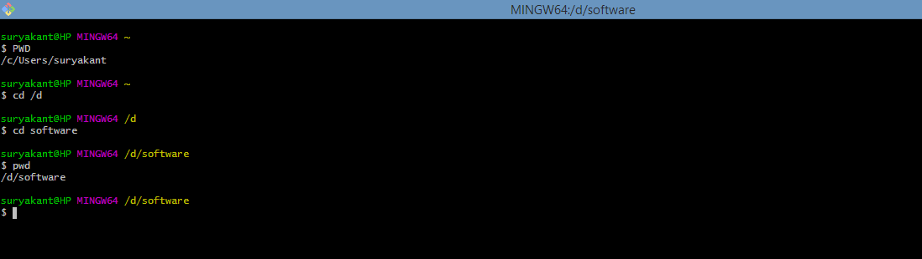

* ls:shows all files n folders from present working directory.

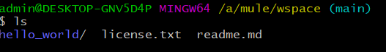

In blue it shows folders n in white shows files.

ls list all the content of the pwd without hidden files .

ls -a : list all the content of the pwd with hidden files .

* vim filename.extension :opens an vim editor to edit the content of file.
* cd /<<directory_path>>:changes the directory(folders).used for jumping between directories(folders).

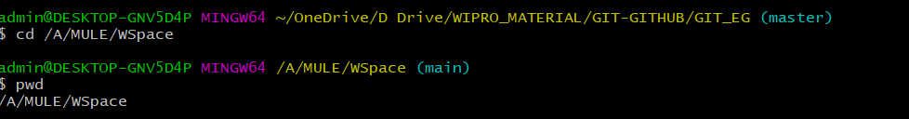

we can use wildcard character like * also like cd he*,cd *lo*, cd *ld

Make sure only exact matched folder name should be entered then only it will be able to switch between the folders, other wise will show error like too many arguments.

Note:if we want to jump to filepath where we are seeing space in folder name,

let say ‘/A/mule workspace’

then if we write cd /A/mule workspace it will give an error saying two many arguments to avoid this we can write command like

cd /A/mule\workspace it will change the directory to /A/mule workspace.

mr

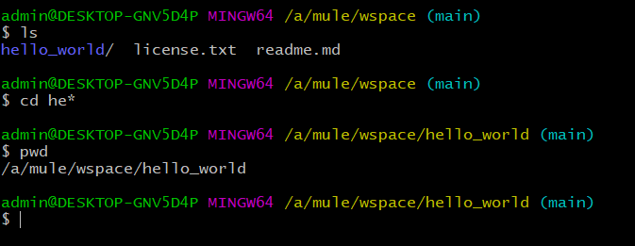

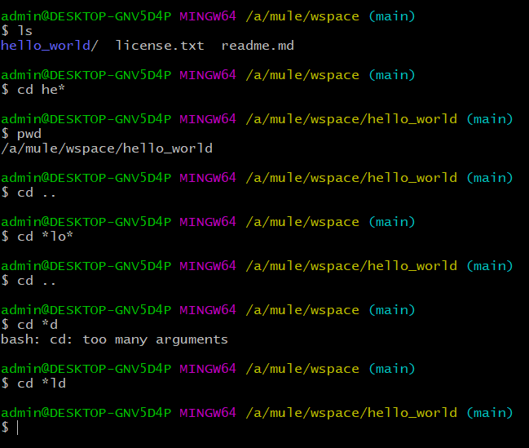

If you want to go reverse in folder level then you can use cd .. command.it will take you to the backed folder.let say currently we are using /a/mule/wspace folder n if I want to traverse back let say to /a/mule then I can use cd ..

stands for change directory .used for changing the directory in which you want to work.

Syntax: cd /c/users,cd /e/installed_files,cd /d/software,cd /b/backup,cd /a this is some directories where a,e,d,b,a are main directories n /users,/installed_files,/software,/backup are subdireactories

Why /c,/d,/e,/a,/b becoz git supports linux style n not windows commands like cd /d c: or cd /d d:/poc

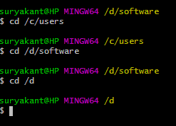 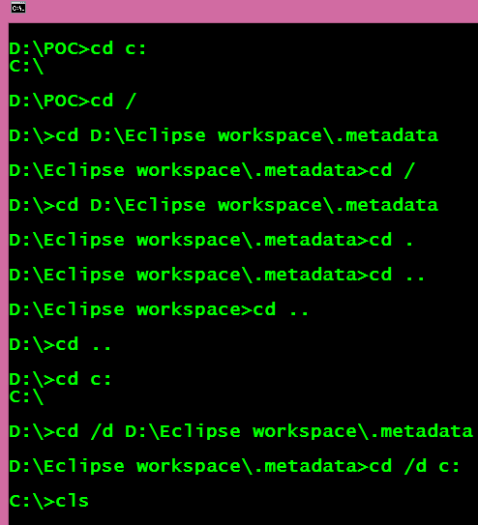

Either you can use cd command to move between directories or you can use one shortcut which is like:-

Go to that directory where you want to work with git in windows

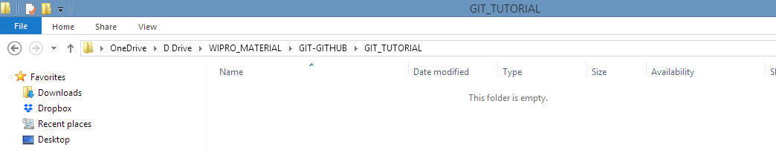

After this right click on blank space

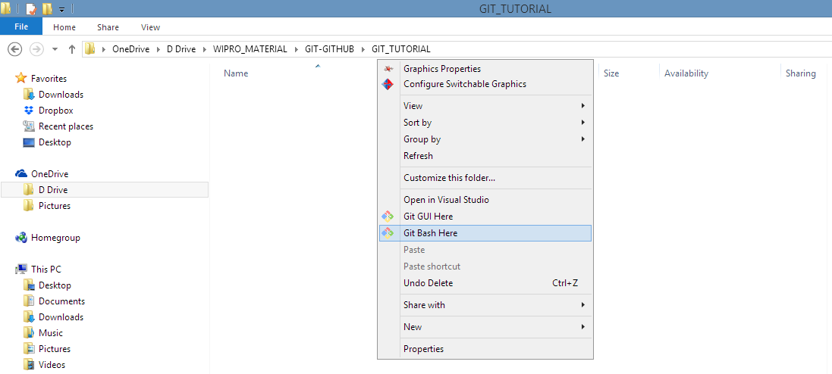

Will open an menu ->click git bash here or git gui here(better to become good coder open with git bash



It will open git bash in that working directory where you want to work. After this you can fire the commands which you want on this directory.

Note:Cd command is only used for jumping from one folder to another.If we write cd first.txt then it gives error like first.txt is not a directory.

* mkdir foldername: creates folder within a system.

Mkdir -p <<foldername1>/ <<foldername2>/ <<foldername3> will create nested folder where folder1 is parent inside that foldername2 n inside that foldername3.

* Rmdir << foldername>>:removes folder from the system if the folder is empty,if not then we can use rm -rf foldername.
* Use of > and >> for sending output to a file

>> stands for add the content or append the content

Eg: echo “hello world” >>demo.txt

Cat demo.txt

Outputs in

Will add hello world in demo.txt file

If we again do

echo “hi user” >>demo.txt

N then do

cat demo.txt

will output in

hello world

hi user

>Stands for override the previous content

Eg: echo “hi”>sample.txt

Cat sample.txt

Will result in

hi in sample.txt file

but if we do again

echo “user ”>sample.txt

Cat sample.txt

Will result in

user in sample.txt file

>> is used for appending the content

>is used for overriding the content

* Cat <<filename.ext>>:shows content/body of the file n not the folders.we can use wildcard character like * also like cat li*.txt,cat *lib*,cat *xt.

Make sure only exact matched file should be one then only it will show the body of the file other wise will show error like too many arguments.

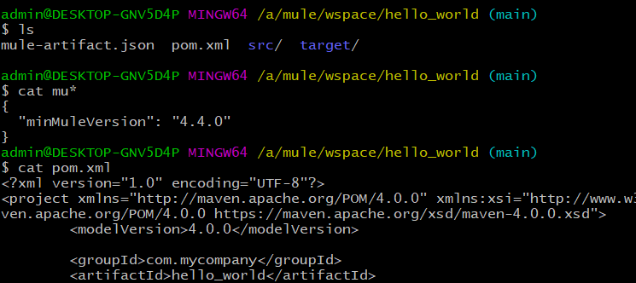

If we say cat folder_name then it will give error like folder_name is a directory. 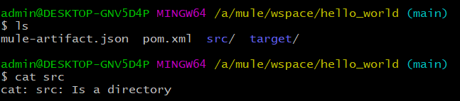

Clear: clear the screen on git bash .it will open a fresh window 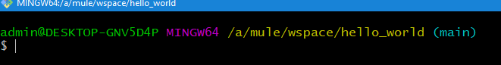 Before clear:

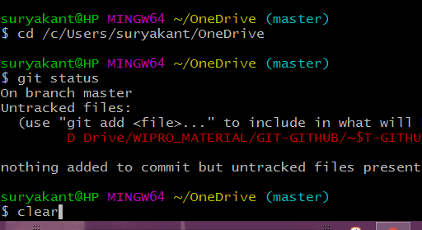

After Clear:-

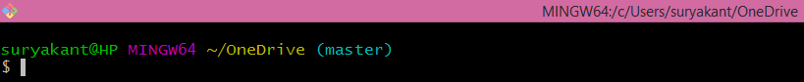

In windows systems:

Before cls:

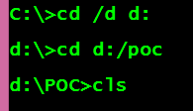

After cls:-



* git config or git config --system or git config –global:It is the command that we will use to set view n edit/delete/removing configuration the parameters.

For setting the values at different levels: use

git config –system user.name “suryakant”

git config –global user.name “suryakant”

git config user.name “suryakant”

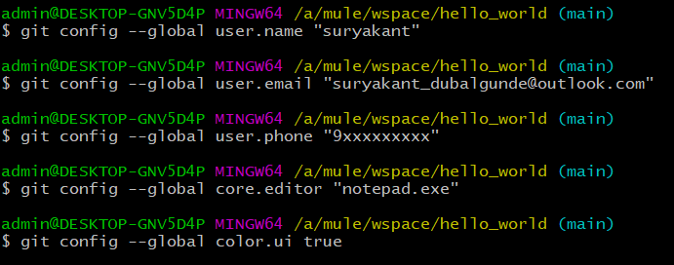

For viewing the values at different levels: use

Particular value: use

git config –system user.name

git config –global user.name

git config user.name

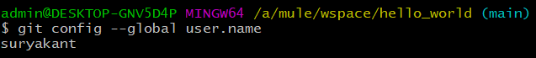

all values at different level:use

git config --system --list

git config --global --list

git config –list(shows all levels config values)

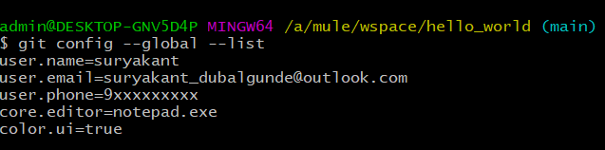

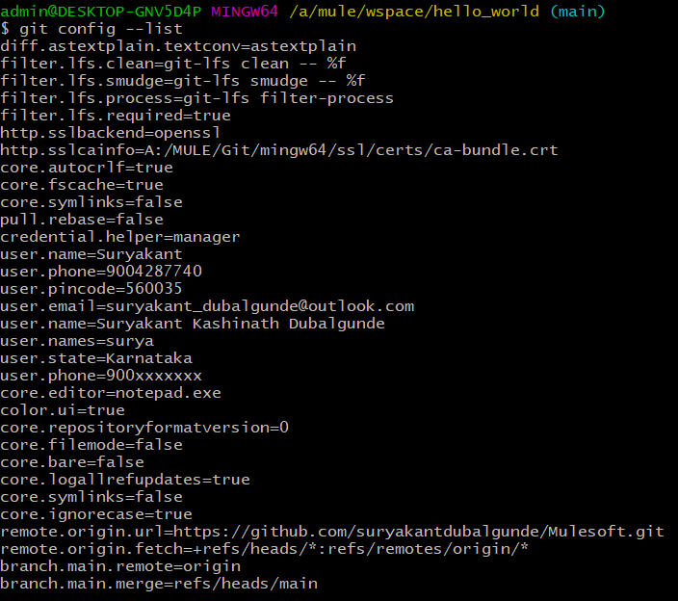

For viewing the values at different levels with label name to identify which level configuration: use

Git config --list --show-origin --system

Git config --list --show-origin --global

Git config --list --show-origin(shows all levels config values)

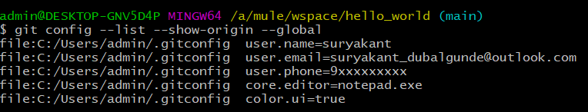

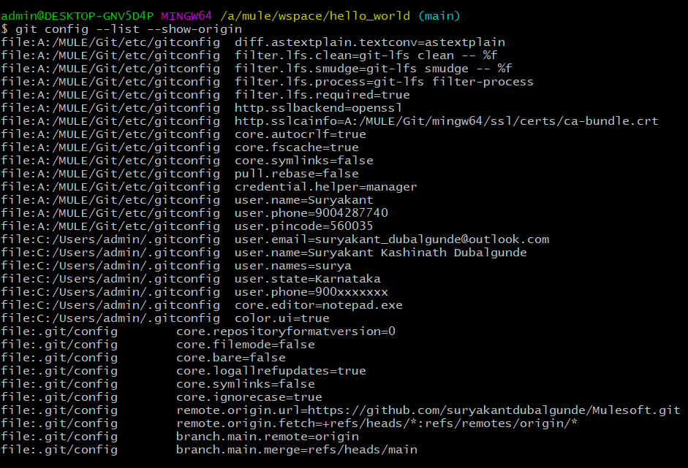

system config= which contains Git/etc/gitconfig in a label

user or global config= which contains user home directory like c:/Users/admin/.gitconfig in a label

project config= which contains .git/config in a label

For editing/deleting/removing the values at different levels: use

git config –system --edit

git config –global --edit

git config --edit

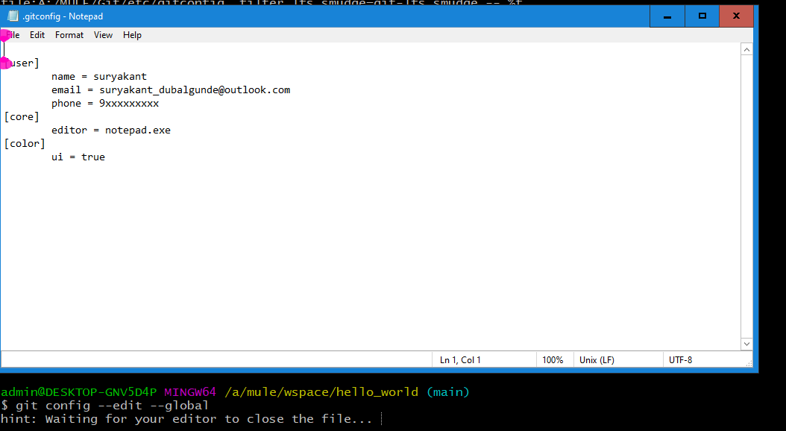

--edit command opens up notepad where we can add new entries,delete the entries or do some changes in the entries.Why notepad opened is because we have set core.editor=notepad.exe as global config that’s why.

* Git help <<command_name>>: this command will help you to understand how to work with the git.only git help command will show all available commands like add,clone etc. 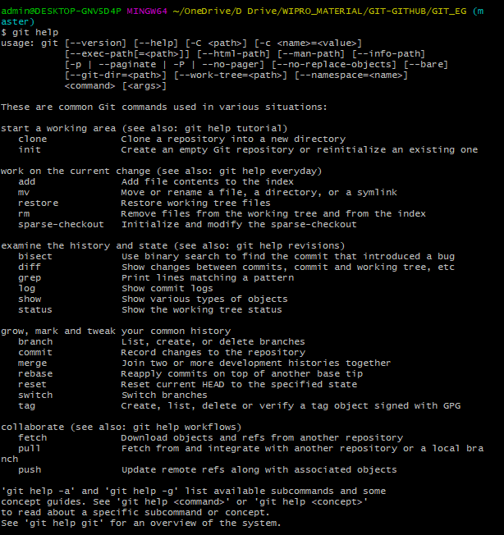

git help <<command_name>> will help you to understand about a particular command.let say we wrote git help add then it will provide information abt add command in git. 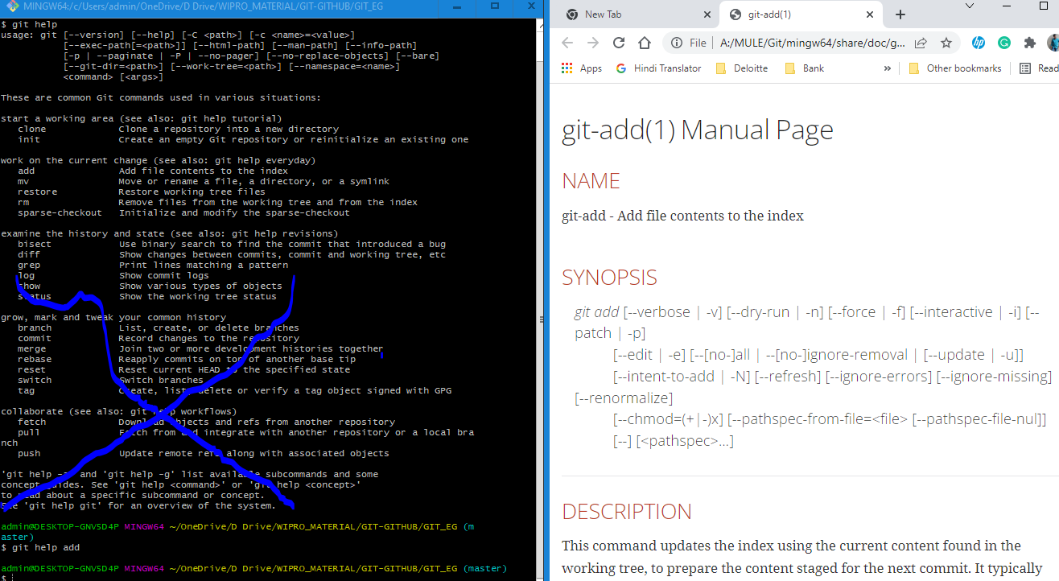

* git init:Used for intializing a git in a project folder.This command creates .git folder in our present working directory that is used to track the changes.if we delete this .git folder or by mistake we throw git init command again it will reinitialize the .git folder again and previously tracked changes will not be available.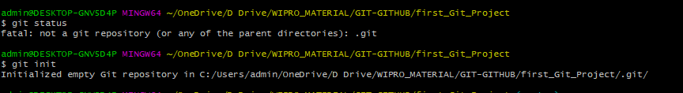

if you dont have an .git folder(Which is hidden) in your current working directory or any parent directory or you will get above error then u use this command to initialize the git repository.

Once .git folder is created ,git will start tracking our files 

If we press git status then 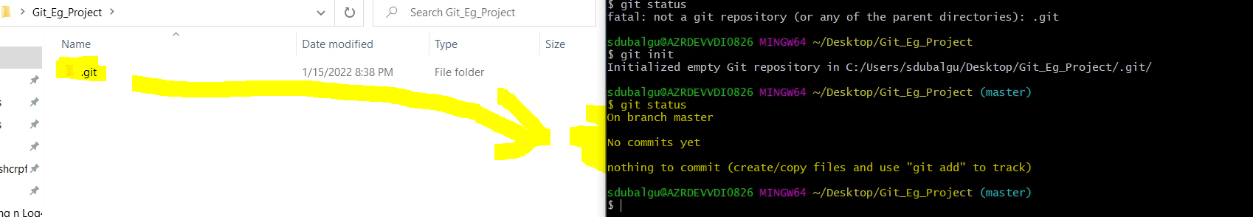

It will start tracking the files in current working directory.

.git file contains below files n folders:

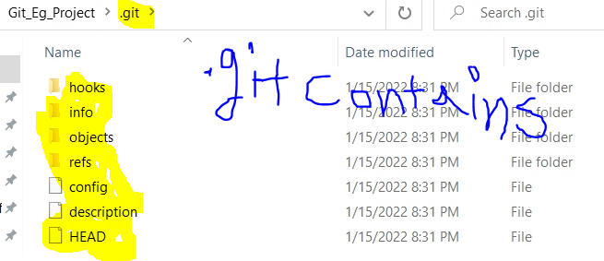

If some files are present in the git_eg_project then it will show untracked files in red which are not committed in git like below img:

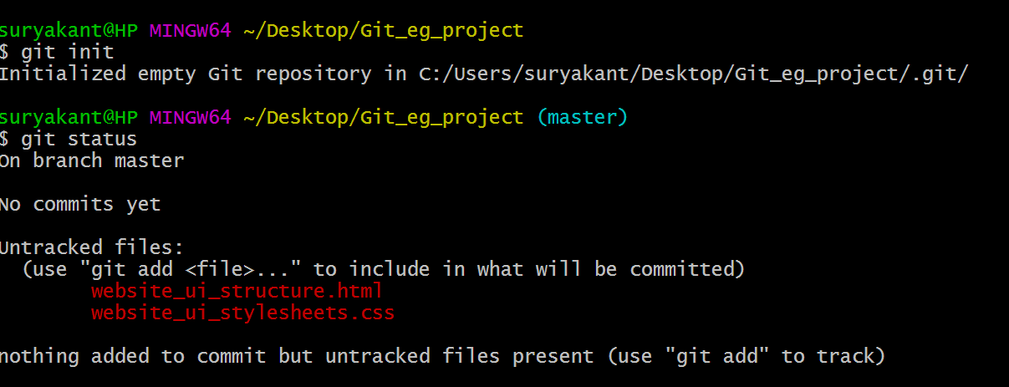

When you add some files or made any changes in the existing .git enabled folder,then to add this changes to staging area or directly commit or save into .git repo

* git status:command is used for checking the status of present working directory like if there any files which are not tracked ,any new file came? Like that tracking. 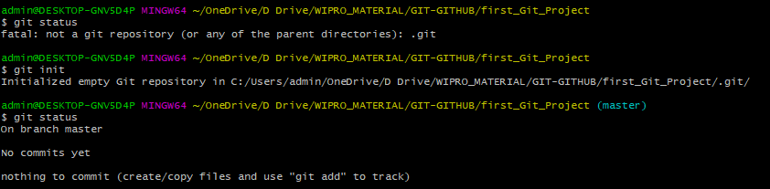
* git add . : command is used for adding present working directory changes to staging area. We can use

git add -p this command is used to show what changes we are going to commit to local repo by showing each file context changes.

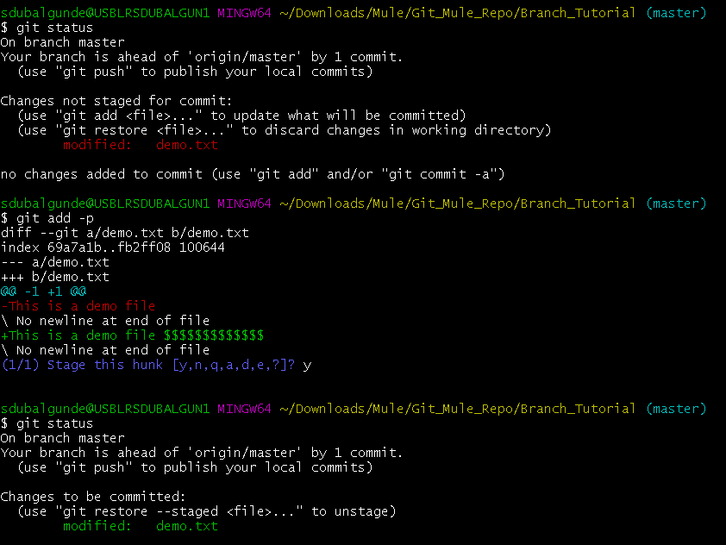

git add . -------------to add all changes made in present working directory to staging area. Or use git add * to add all changs in staging area.

git add <<filename.ext>>-----------------to add only filename.ext change from present working directory to staging area.

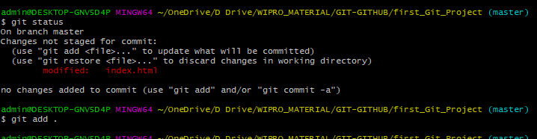

Note:If we are adding something new let say we add two new files in our project so when we do git status, we get those file names in untracked files becoz those files are not been tracked by git by using git commit command. The file which was we tracking in below case index.html is already been tracking by git so it will show as changes not staged to commit .

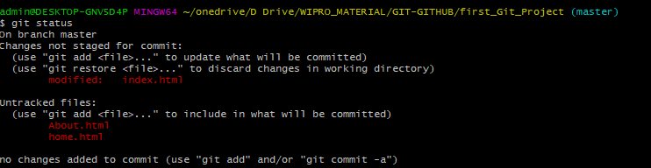

Let say we have 2000 files which we got changed in pwd n out of those only files which have html extension or any other condition like files stating with a or files contain hub, that needs to be staged then we can do it by using below command

git add *ml or git add a* or git add *hub* 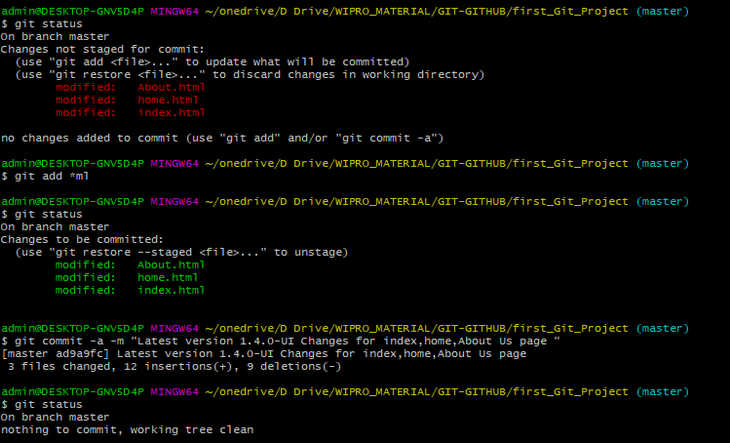

let say we have 5 changed files in pwd n need to staged only two files,we can do it by adding their names in git add command like below

git add home.html About.html 

* git commit -m “commit_msg”: once we add the changes to staging area ,final stage is commiting it to repository.that we can do by following command

Git commit -m “commit_msg”

Where -m stands for message

*If we just write git commit n then press the enter it will open an editor what you selected n configured in config files to write a commit msg .if we close the file without writing a commit msg it will discard the command (git commit)

Commit msg should be in present tensen always should be enough to understand for what purpose changes are made.eg:

GHI#2345-Fixes bug in a admin login portal

Where GHI stands for Github Issue

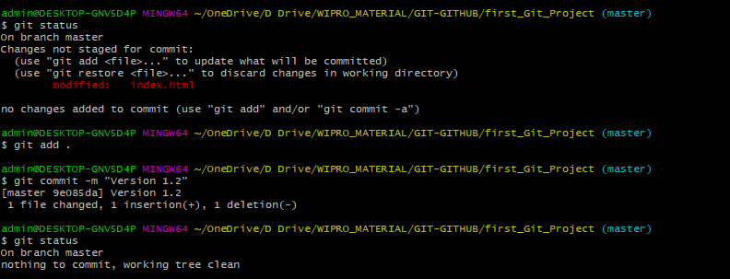

Note that without adding a change/set of changes to staging area by using git add . we can directly commit the change/changes to .git repository by using below command with -a option(all changes should be tracked to directly commit to the git repo.If we have two changes let say file1 is tracked by git already n file2 we have just addedd in our working directory so if we try to commit this changes directly by ignoring git add cmd then only file1 will be commited to git repo n file2 will still be an untracked changes.to make it like file1 we first need to add file2 in git tracking by entering git add cmd.

Git commit -a -m “commit_msg”

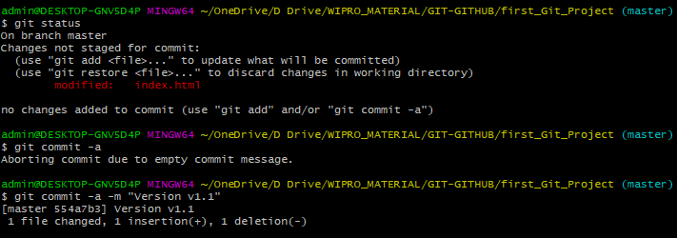

When we commit the changes to repository ,git generates hash value(SHA-1 value or 40 character Hex value[0-9,a-f]) based on content of the changed file.for eg:-

490c6101a87af9deeece859c42b4b4bb780f7df6

* git log:this command shows logs of all commits made in the repository ordered by most recent commits.

git log -n 2------------------shows logs of 2 most recent commits

git log –since=2021-01-01------shows logs of all commits since the specified date to till today.

Git log –until=2021-01-01------shows logs of all commits untill the specified date.

Git log –author=”surya”--------shows logs of all commits created by specified author.

Git log –grep=”init”--------------shows logs of all commits where commit msg contains specified string value in grep where grep stands for global regular expression.

Git log –oneline--------------Provides list of all commits in one line like below scre enshotorder by most recent.

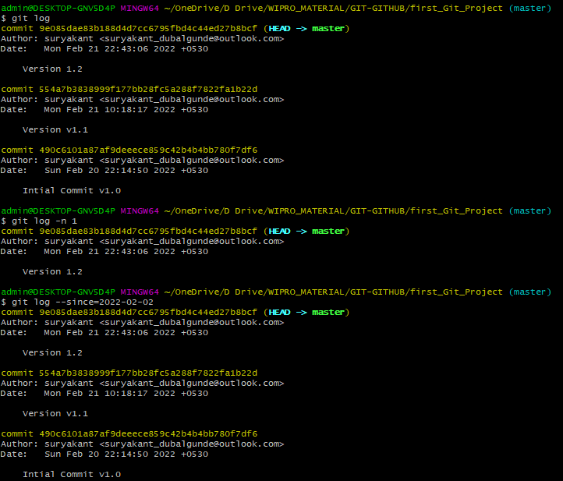 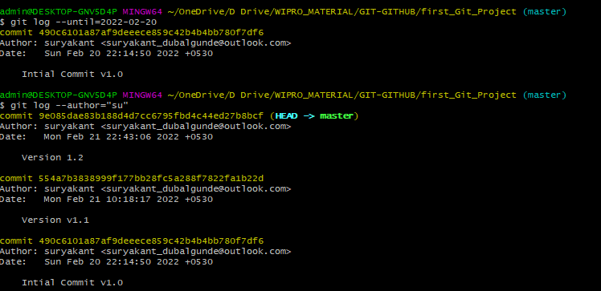 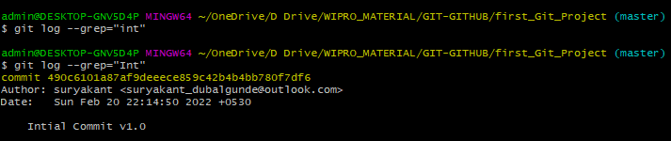

Note that –grep=”” value is case-sensitive. 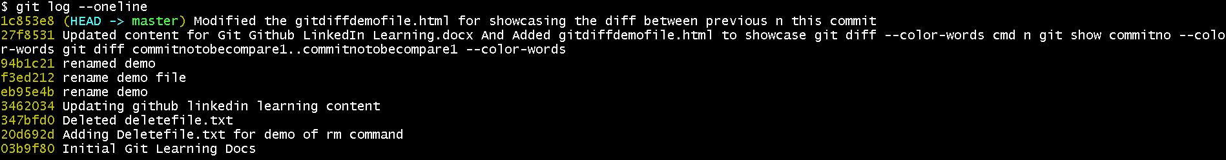

* Git diff / git diff --staged:this command is used to view the changes which we have made in our pwd files.

(++) or green color indicates content that has been added

(--) Or red color indicates content that has been removed

Git diff –color-words will highlight only the changed content(red color=removed content, n green color=added or modified content) n not the whole content in red n green color.

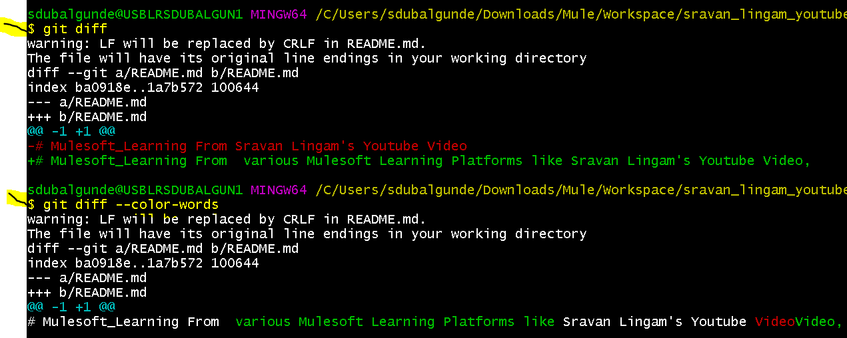

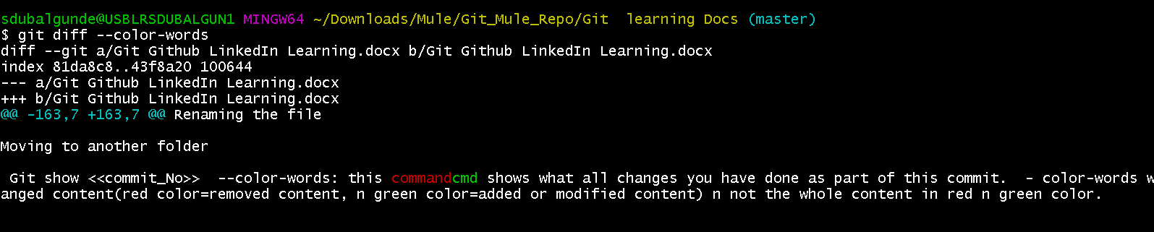

to view the changes in one of the file let say explorers.html out of so many changes in bunch of files we can view the changes by using below cmd

git diff –color-words explorers.html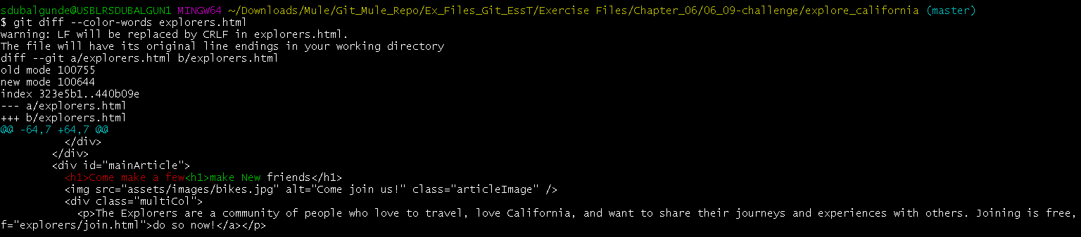

To show the diffences of content in pwd git uses Git diff . git diff command compares pwd file n staging area file copy for this .

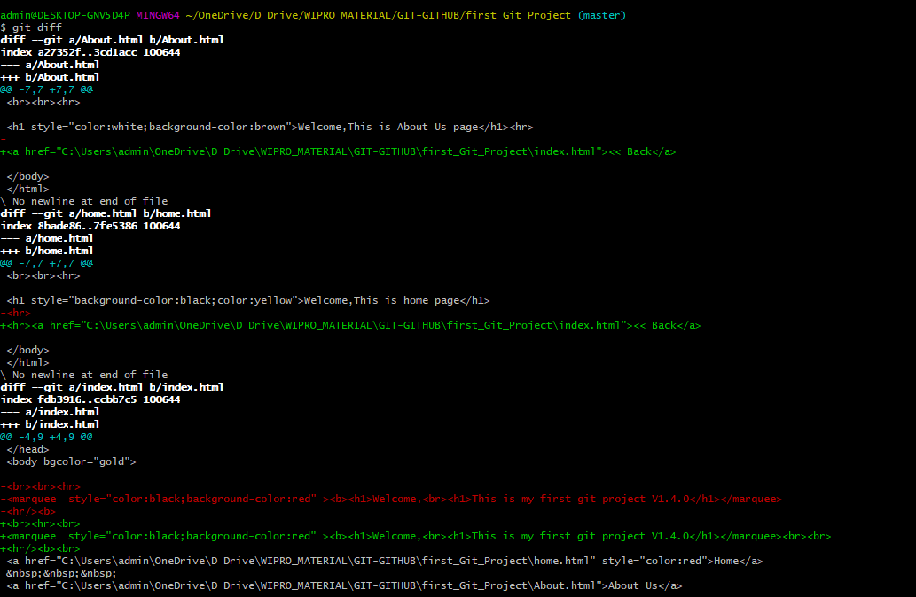

Git diff –staged command is used to see difference between staging area file n git repo file..it compares staging area file n git repo file.

So to compare the changes between pwd file changes n staging area file write git diff

To compare the changes between staging area file n git repo file write git diff –staged.

* Notepad <<filename.ext>>:will open a notepad n will prompt whether the file exists or not,if not then it will create a new file with the filename provided then we can write any comment in the file.If file exists then it open for editing the file.To create a file directly from comand line we can use this command.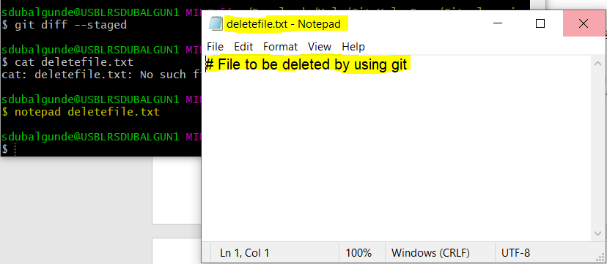
* Git reset /git restore/git restore --staged:this command is used to bring the changes back to their previous status.

Git reset . this command is used to bring the staged changes(git add) return back to unstage(pwd) same way

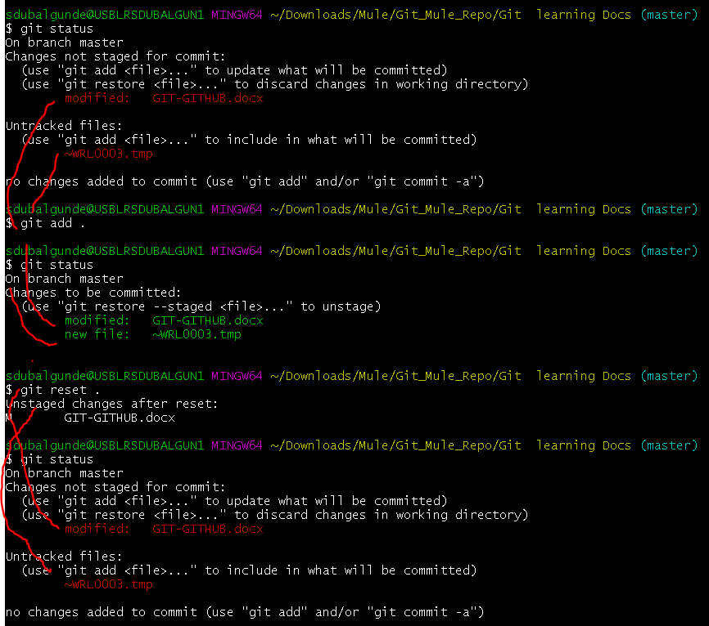

Git reset –soft HEAD~1 is used to undoing a commit. That is once we do the commit n if we want to undo the commit then

Git restore –staged . is also used for to bring the staged changes(git add) return back to unstage(pwd)

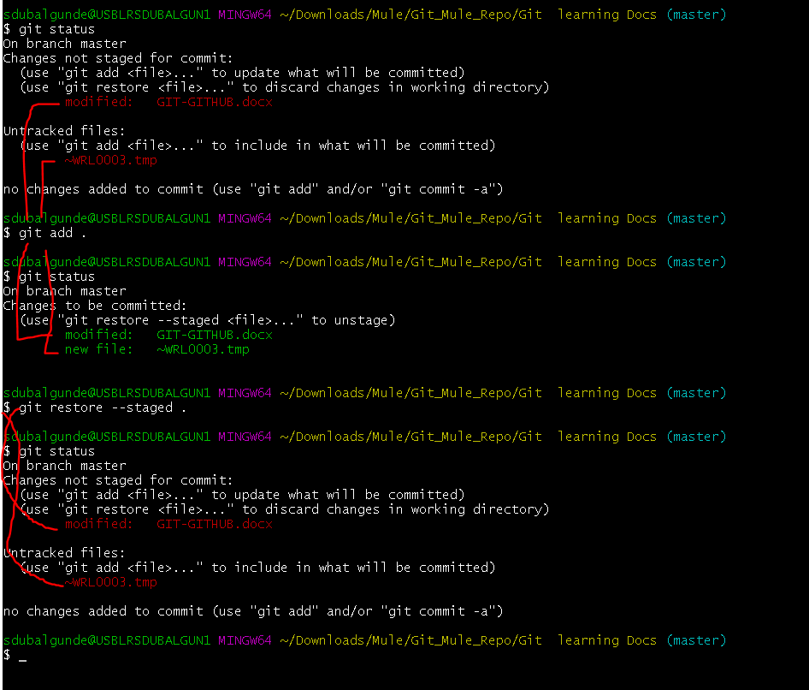

While git restore . /git checkout . is used for discarding the saved changes in pwd .condition is that the file should be tracked by git it should be in untracked files .

* Git clone <<github url>>:this command is used to copy rhe git repo to our local system. 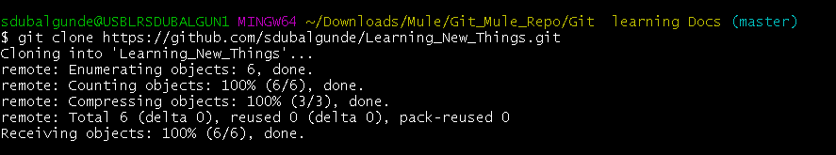

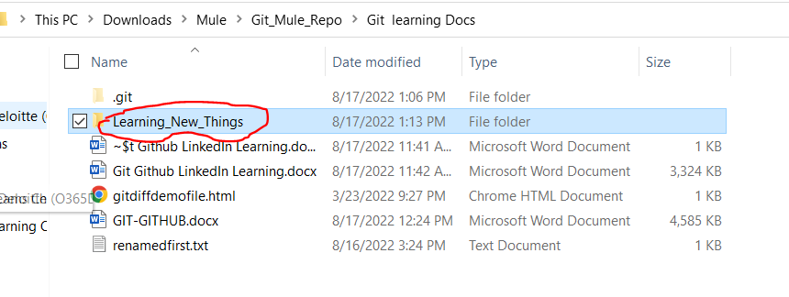

* Touch a.txt: this command creates a file with a.txt name.
* git remote add origin url_of_git_repo: connects ur local sys repo to git_repo here origin is alias name for the url of git
* git push -u origin branch_name: it pushes the changes from local repo to git origin’s (url_of_git_repo) branch name.
* git pull origin branchname: it pulls the changes from git repo origin’s (url_of_git_repo) branch name to local repo.
* Git branch: gives list of branches.



* Git branch <<branch name>>:creates branch with specified <<branch name>>.

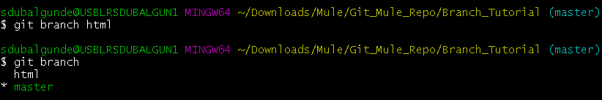

* Git checkout <<branchname>>:used for switching the branch as we switch the branch the contents also changes according to switched branch.

We can use

git checkout -b <<branchname>> so that it will create and checkout the newly created branch in one command.

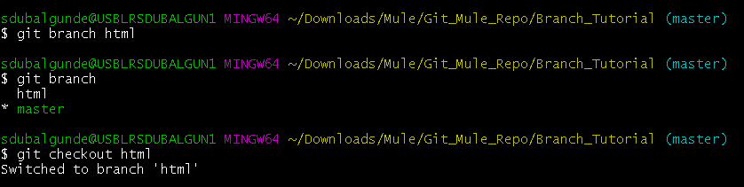

* Git merge <<branchname>>:used for merging the changes from <<branchname>> to already working branch(master)

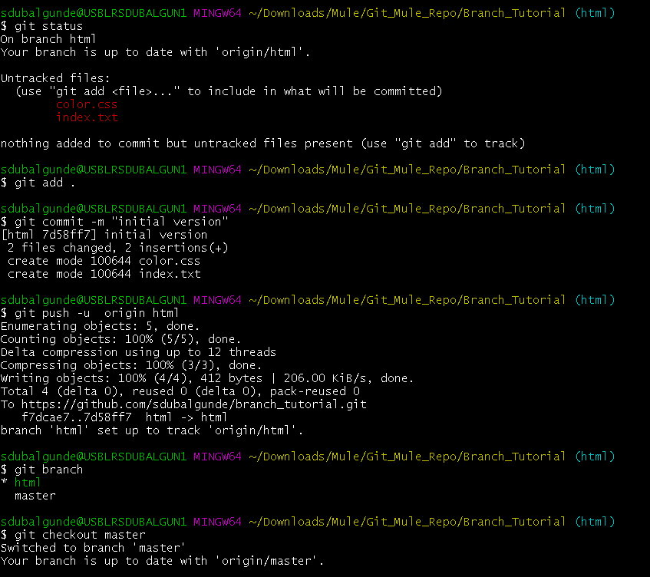

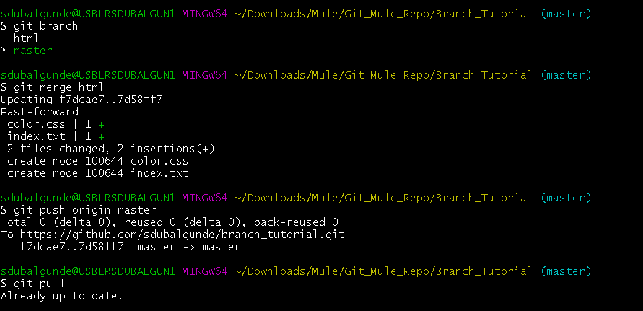

* Git branch -d <<branchname>>:is used to delete a branch from local repo

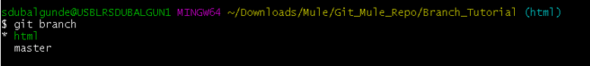



We can use

Git branch -D <<branchname>> if with -d we are getting an exception while deleting the branch.

* Git push origin –delete <<branchname>>: to delete a branch from github repo also then you use this command.

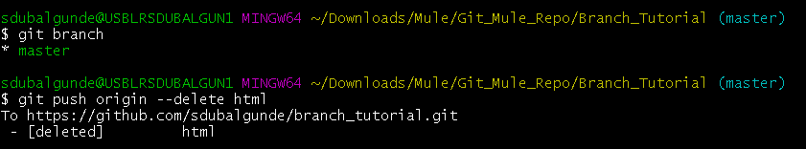

* How to set alias for any git commands

Git config –global alias.<<aliasname>> ‘git command’

For eg: git config –global alias.show1log ‘log -n 1’

Then to use show1log alias

You can type

Git show1log

Result will be git will show the most recent 1st log

git config –global alias.st ‘status’

git st

git config –global alias.add ‘add .’

git add

* Exit: it is the command which is used to close the gitbash window.
* How to configure notepad++ for using as an editor

Copy the notepad++ filepath till C:\Program Files\Notepad++

N then add this path in environmental variables under system variables->path variable->click on ok two times->then open gitbash n use notepad++ command it will open notepad++ window to edit.

* Rm <<filename to be deleted>>:command is used to delete a file.
* Git revert <<commitno>>:Revert all files back to a previous commit point

git revert <long commit ID from the **log** command>

* Git stash: this command is used to stash(save) our changes temporarily n switch over to another branch while do not bringing that changes to newer branch.

Git stash list is used to view all stash changes

Git stash apply <<stashno>> to apply the stash changes

Git stash pop popups the stash changes

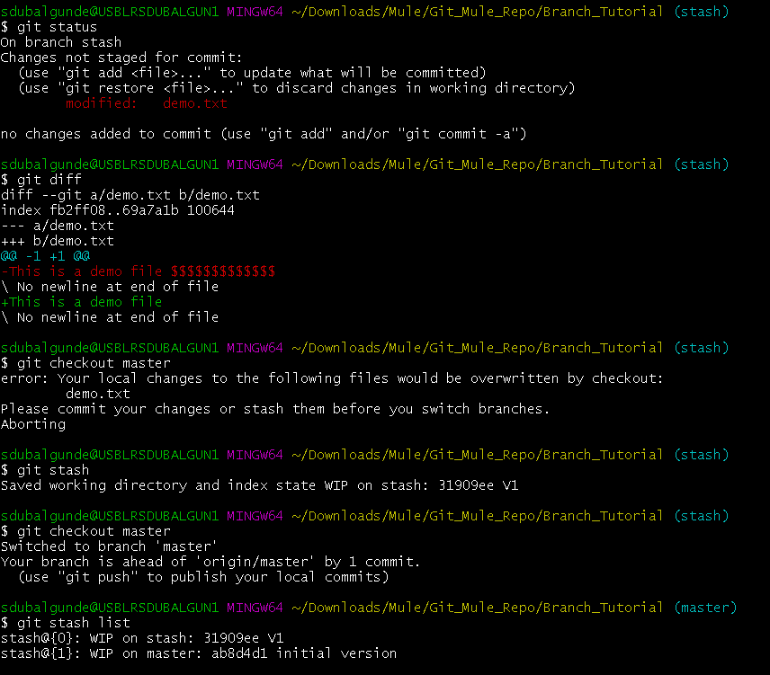

* If you hit . [period or full stop ] on any remote repository(github) while u were on the repository you will be redirected to github.dev site-an editor
* Git rm <file_to_be_removed>:rm command is a unix command which is used to delete particular file. Git rm deletefile.txt will remove the file from local repo and will directly add this delete file change in staging area. 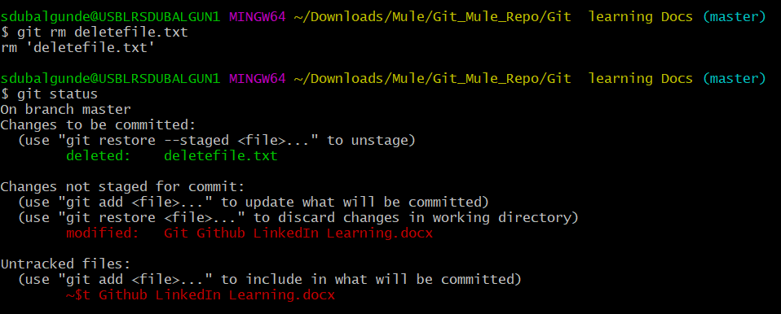

To add this delete file change in git repo,we need to commit this change by using below cmd:

Git commit -m “commit_msg” 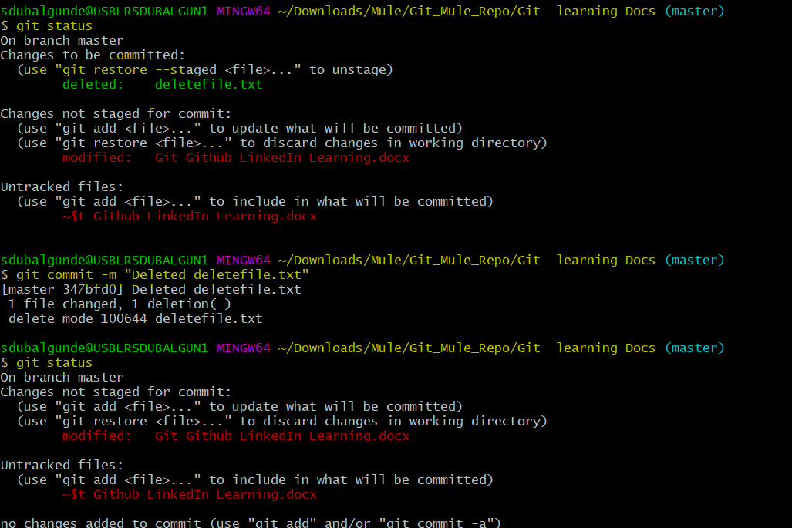

* Git mv <<filename to be renamed>> <<New filename>>:this command is used to rename the files.move or rename are same only because in rename we are renaming the file so indirectly the path will change for that file + in move we are moving a file from one place to another so directly it changes the path of the file.so we can use this command for moving n renaming the file.

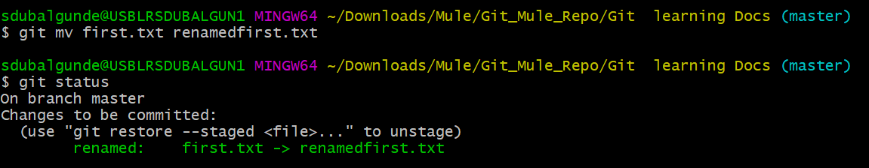

Renaming the file

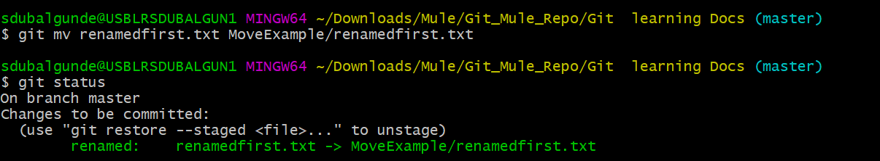

Moving to another folder

* Git show <<commit_No>> --color-words: this cmd shows what all changes you have done as part of this commit. –color-words will highlight only the changed content(red color=removed content, n green color=added or modified content) n not the whole content in red n green color.

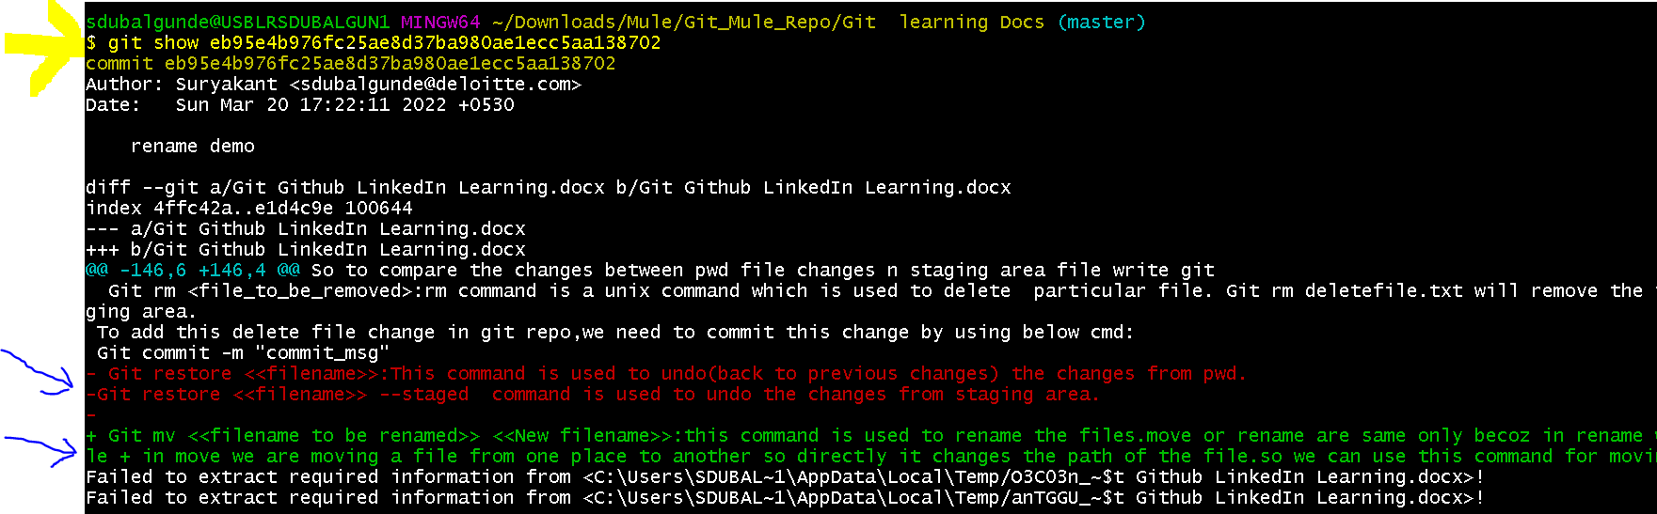

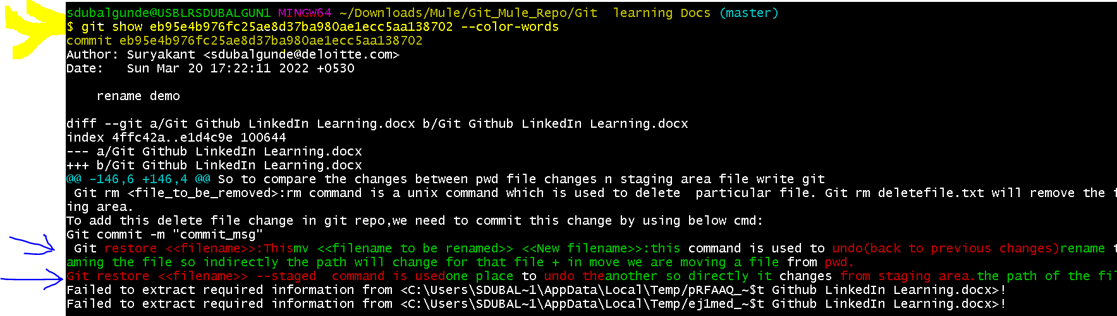

* Git diff <<oldcommitno>>..<<newcommitno>> –color-words: will help to compare two commits it will highlight only the changed content(red color=removed content, n green color=added or modified content) n not the whole content in red n green color.
* 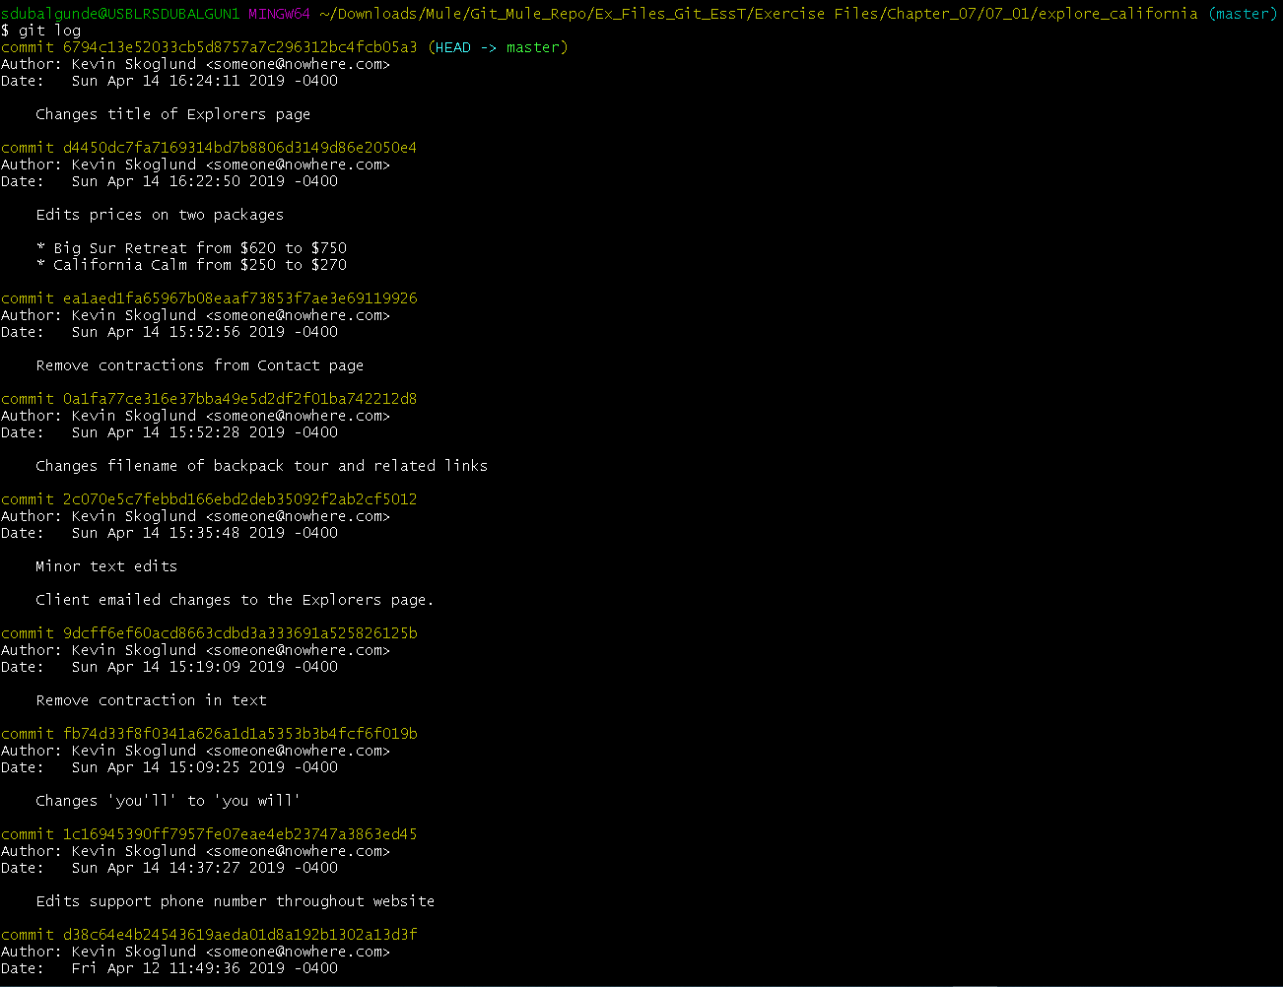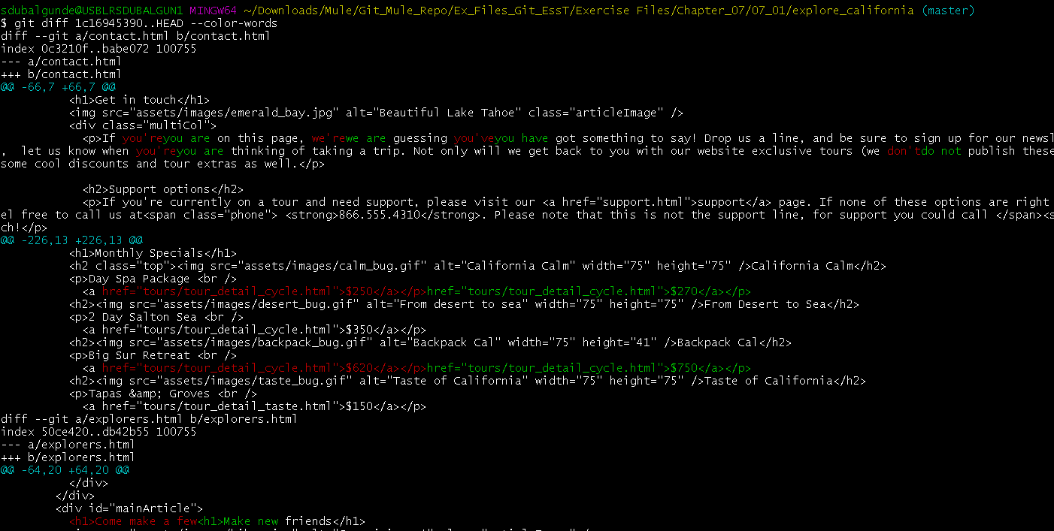

As we know,HEAD refers to Current Commit so we are comparing old commit i.e. 1c16945390 n the latest commit i.e HEAD =6794….

* Multiline commit messages:to provide multiline commit message what we can do is we should not specify -m <<commit_msg>> in the command like we can type git commit or git commit -a.After we click on enter it will open an code editor of our chosen one n there we can specify commit message in multiple lines. If we don’t do anything then commit will be discarded or aborted.

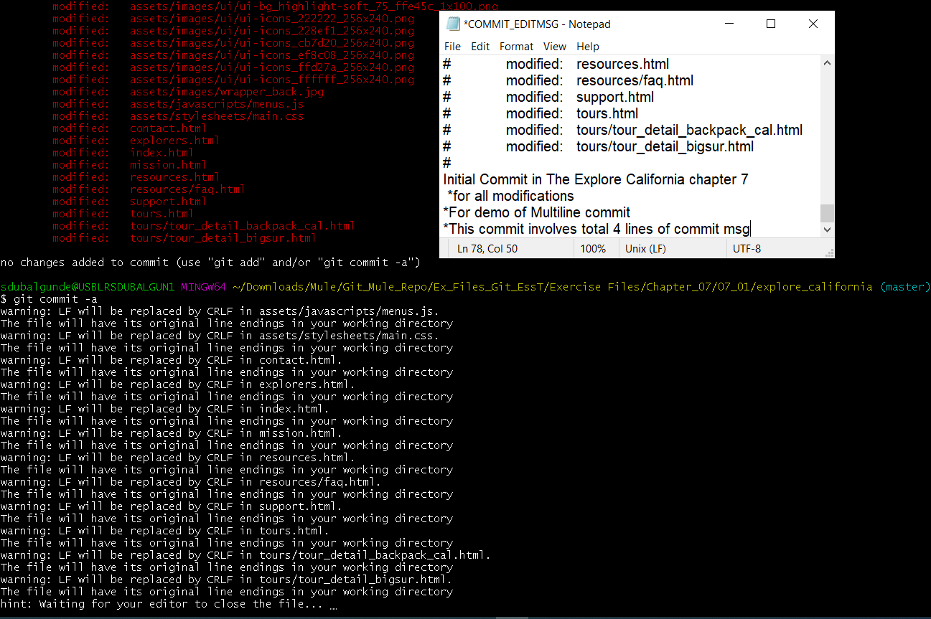

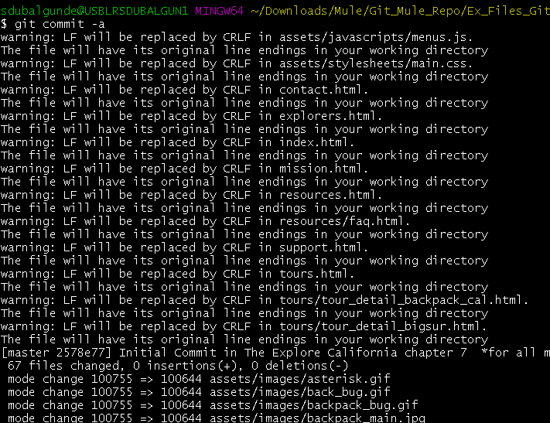 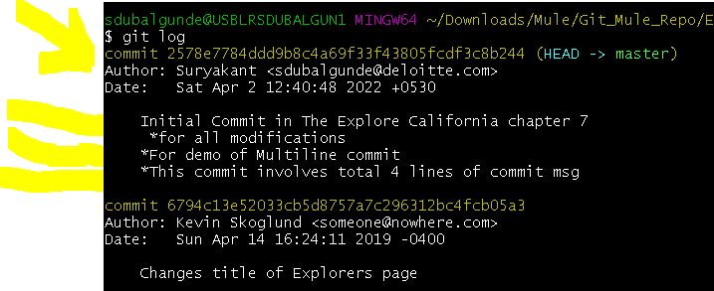

* Git checkout -- <file_nm> or git checkout -- . or git restore -- <file_nm> or git restore -- . : this command is used to undo changes from working directory i.e. to discard changes in working directory .For eg:-Let say we make an modification like below in index.html file n saved that change n close that file then again we opened so get back those changes we cant do undo there.with git tracking your changes we can know what was the earlier content n what has been modified to what with below set of commands.Remember here that we haven’t added that changes still to staging area(git add) or local repo(git commit). 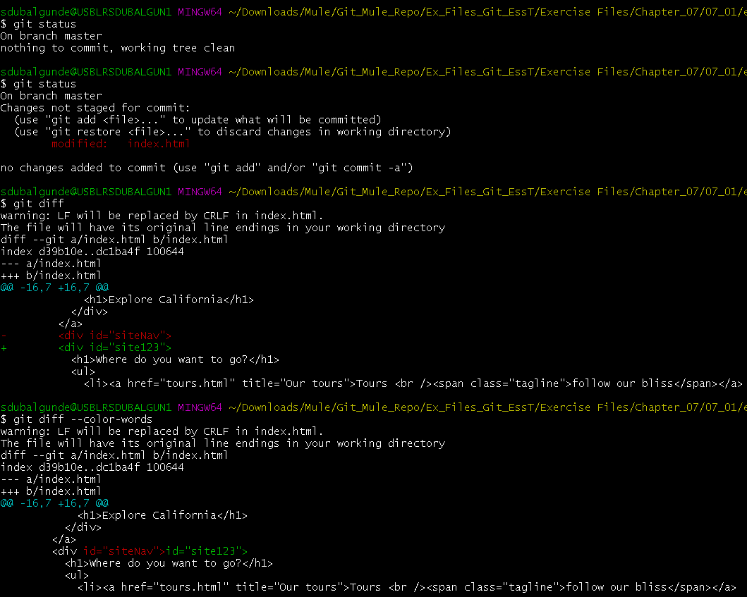

to get back those changes in a working file we can use mentioned cmds.Index.html file before applying the checkout/restore cmd

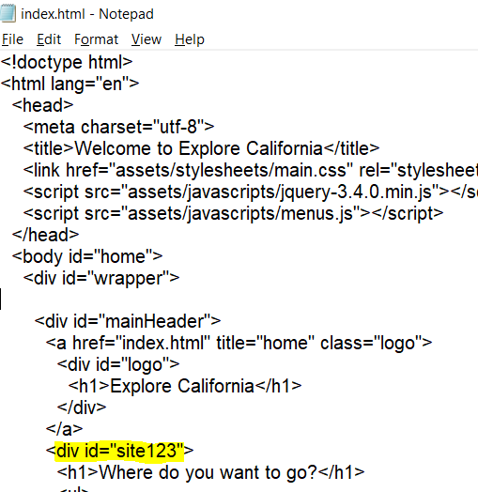

Index.html file after applying checkout/restore cmd 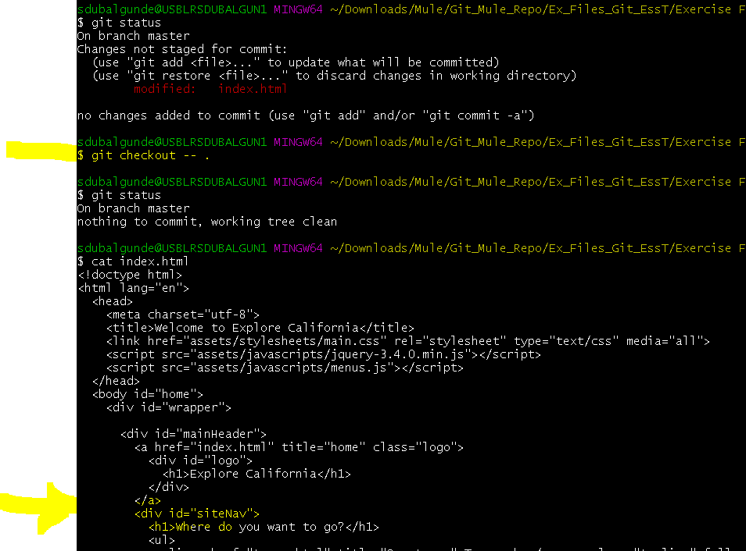 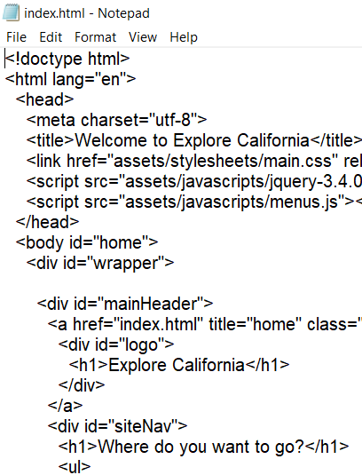

Before applying restore cmd

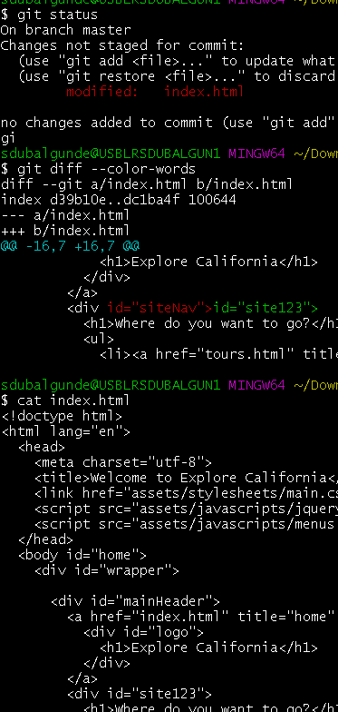

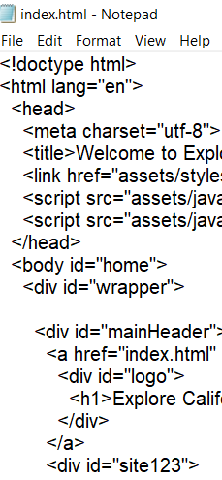

After applying restore cmd index.html file.

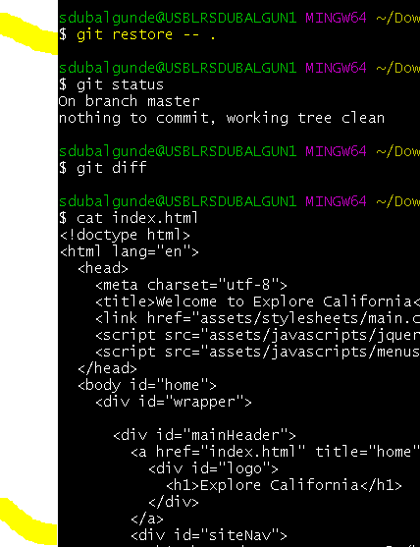 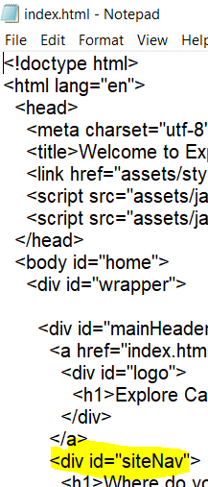

Indicates current branch(--)

* Git reset head <filenm> or git reset head . or git restore –staged <filenm> or git restore –staged . :this cmd is used to unstaged the changes from staging area.(if we do some change in working directory n then add those changes in staging area(git add) then if we want we can unstage those changes by using mentioned cmds.

Using Git reset head . cmd

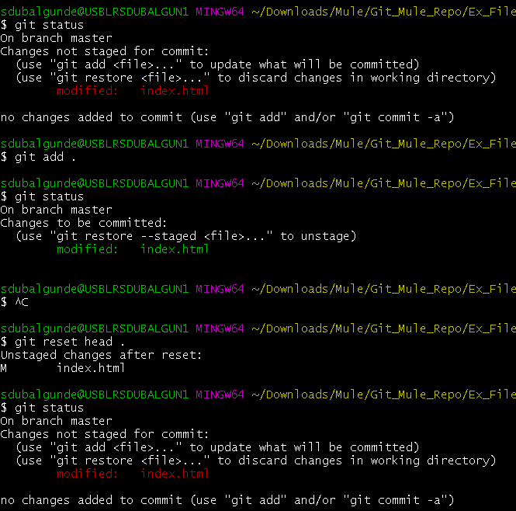

Using git restore –staged . cmd

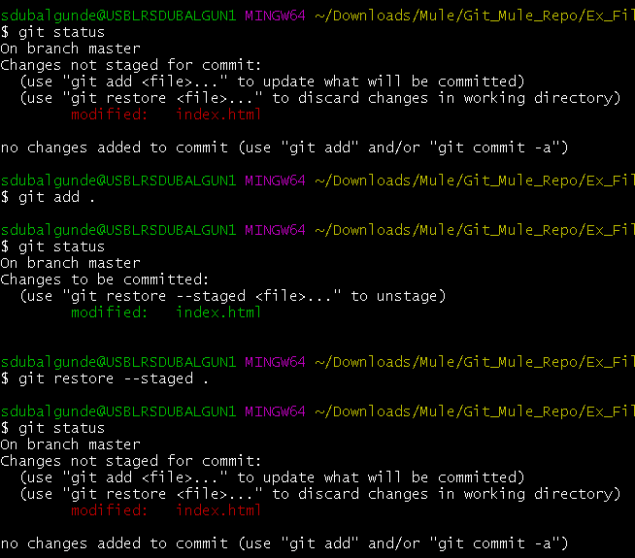

* Git commit –amend:this command is used to modify the comment/content of a most recent commit .content can be like commit_msg,commited changes .whenever we use –amend then the original generated most recent commit’s SHA value will be replaced by the newest SHA value because we will change most recent commit comment/content.should be used before pushing to remote repo.

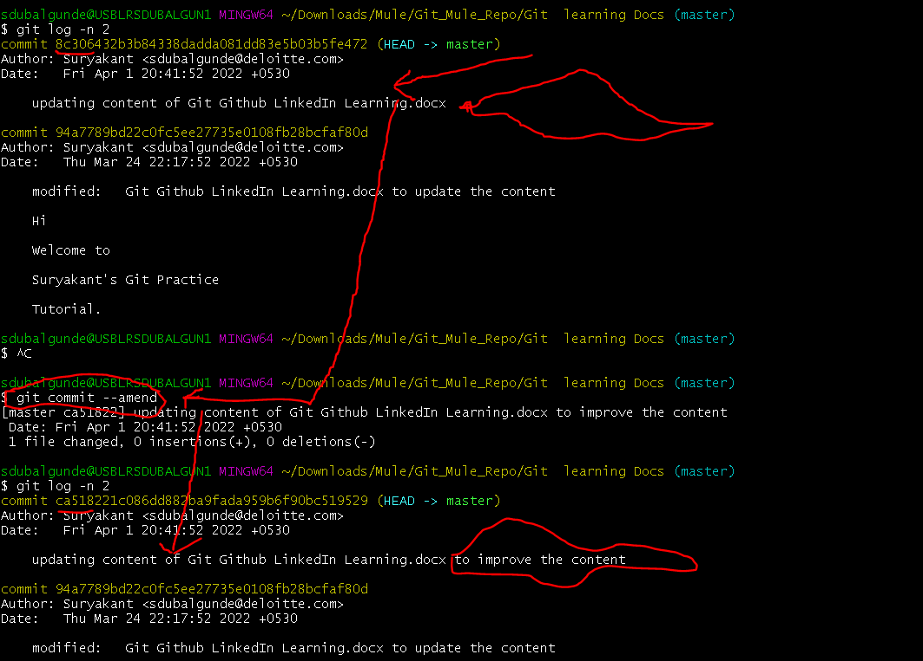

* Git clean: this command is used to clean the untracked files from the directory.

Git clean -n:would give you suggetion like which files could be deleted but it does not actully performs this action.

Git clean -f : will directly deletes all the untracked files.

* .gitignore file: this is a file which gets tracked by the git but the name of the files that we provide in .gitignore file wont be tracked unless they are tracked by git before .gitignore file is created n tracked by the git.

We can add file names/file path which we don’t want to get tracked by git eg:

Log.txt

/src/main/resources/*

*.txt

.ml*

Log[0-9].txt

When we untrack the files using .gitignore file we do this @project level only but what if we want to untrack files @global(specific user level) or @system(all user level) then we can do this by

Git config –global core.excludefile ~/.gitignore[gitignorefilepath@global path]

If we want git to don’t track the tracked filesthat were tracked before .gitignore file tracked,that we can do by

Git rm –cached filename.extension

We know that git never tracks an empty folder so let say we have one project folder inside that we have so many subfolders n all folders are having files inside it except one folder so that folder wont be tracked unless we add some files to that folder to do that what we can do is

We can create an .gitkeep git.

**GitHUB**

* GitHub is a collaboration platform built on top of GIT that means internallly GitHub uses GIT functionalities.
* To start wiith Github,we need to have an github account so lets create it by redirecting to

[Create Github account](https://github.com/)

Once you create account and sign-in you will see below screen

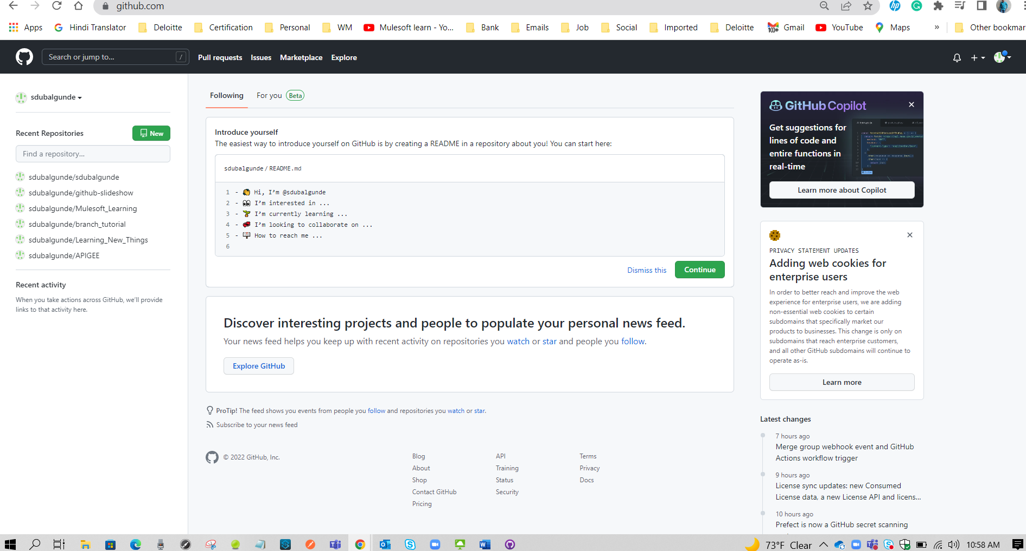

GitHub provides GITHUB for Desktop application which can be installed on desktop n then we can start working with github. To downoad [Download GitHub For Desktop](https://desktop.github.com/)

Once downloaded open the exe file n then provide ur github.com creds

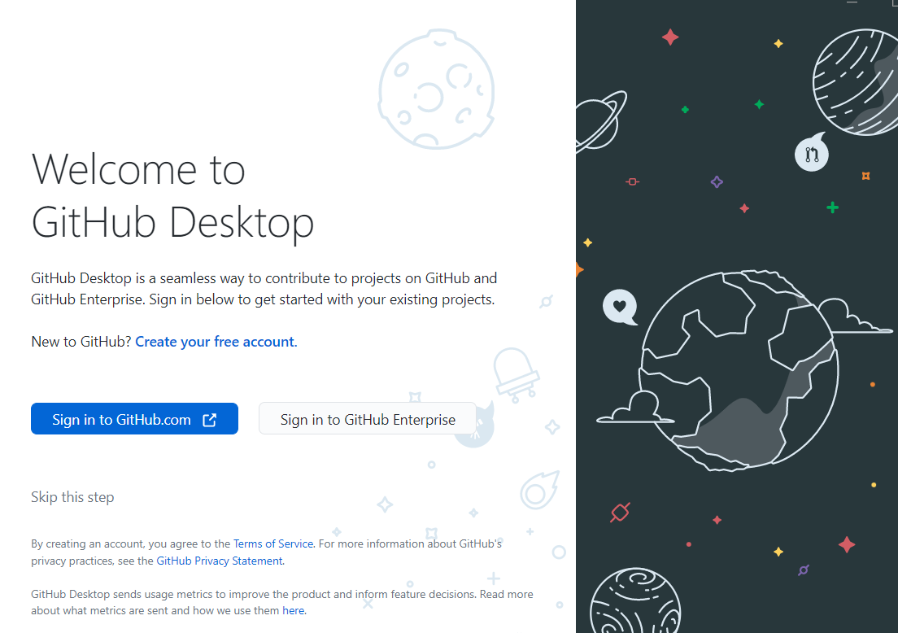

Once logged n with github creds will see below window

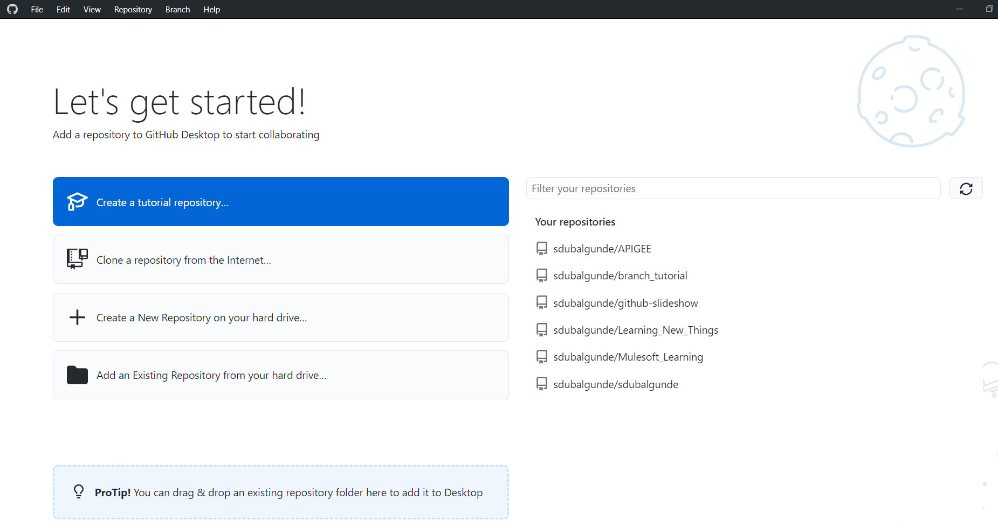

* To create a repository in your github account,

Click on + symbol on top right corner n select new repositories and follow the instructions.

Once you create a repo u will see below screen

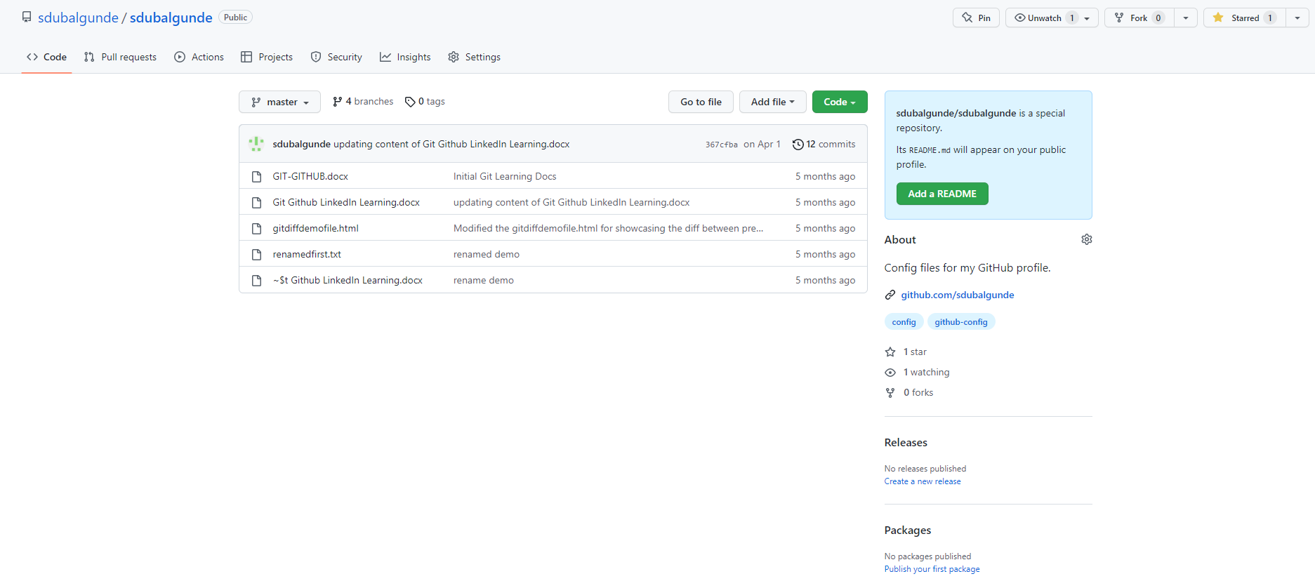

* To clone repository in github desktop

Go to github.com repository u want to clone->in the code tab click code button ->select open with github desktop.IT will open an window in ur github desktop app where u can specify the local path to create the repo n then click on clone button.it will create a local repo in ur system n then you can make changes by creating a new branch n then pushing the changes back to github.com

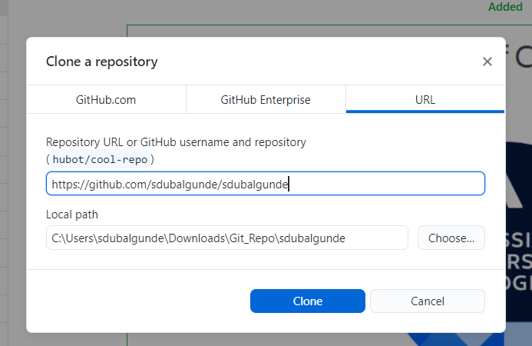

* How to create a branch using Github desktop

Go to top of the github desktop three u can see current branch option,click on that n type ur new branch name then click on new branch->on the next window it will ask the branch name which will be base branch for this new branch(that means from which branch you want to copy the data n work upon).

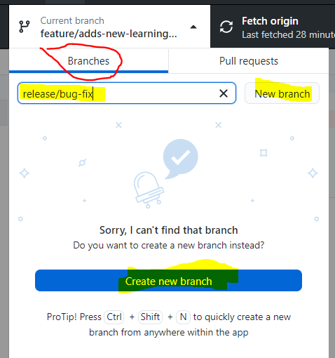

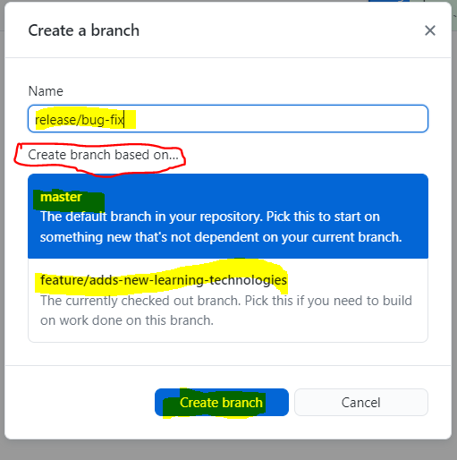

(by default Master/main branch will be created n it is the default branch created when we create a repo.we can change the name in account level settings(which will apply to all repositories) or at particular repo level(applies to that repo only)

@profile level :

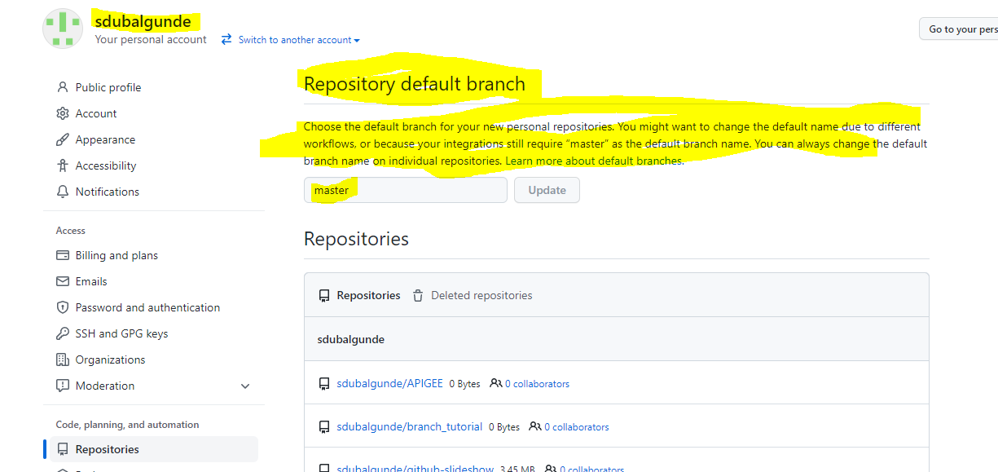

@repo level;-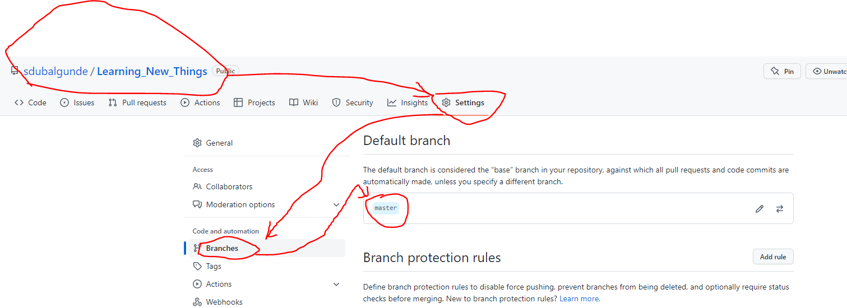

* Once branch is created you can push this an empty branch to github.com by pressing publish branch button right side of current branch or you can publish this branch after doing the changes at committing time.Untill n unless you publish the changes,the branch n changes wont be visible in github.com. apart from that we can view the files with code editor or in system explorer n on github by selecting the options shown as below

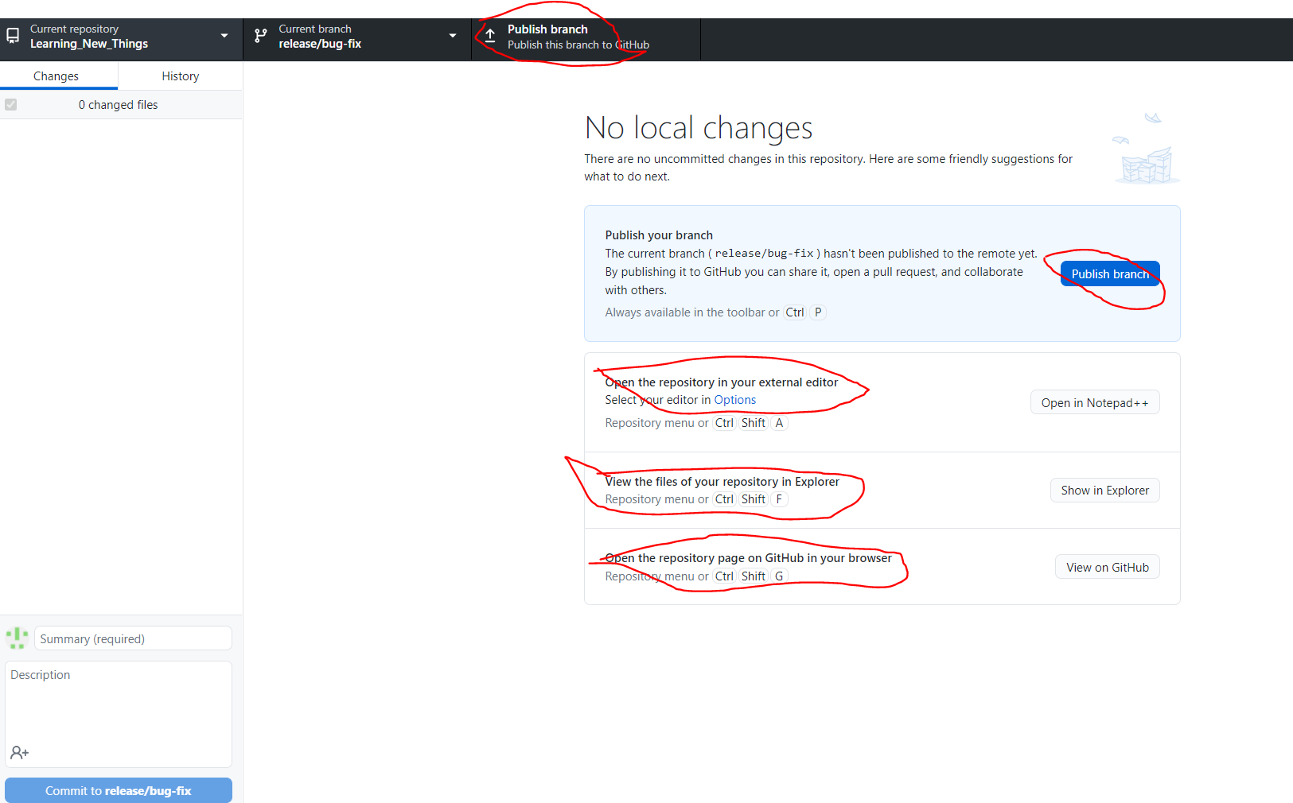

* Doing changes in a new branch:

We can update/modify the files,add new files ,delete the files.as we perform some changes github desktop will capture those actions n will indicate in an app like below

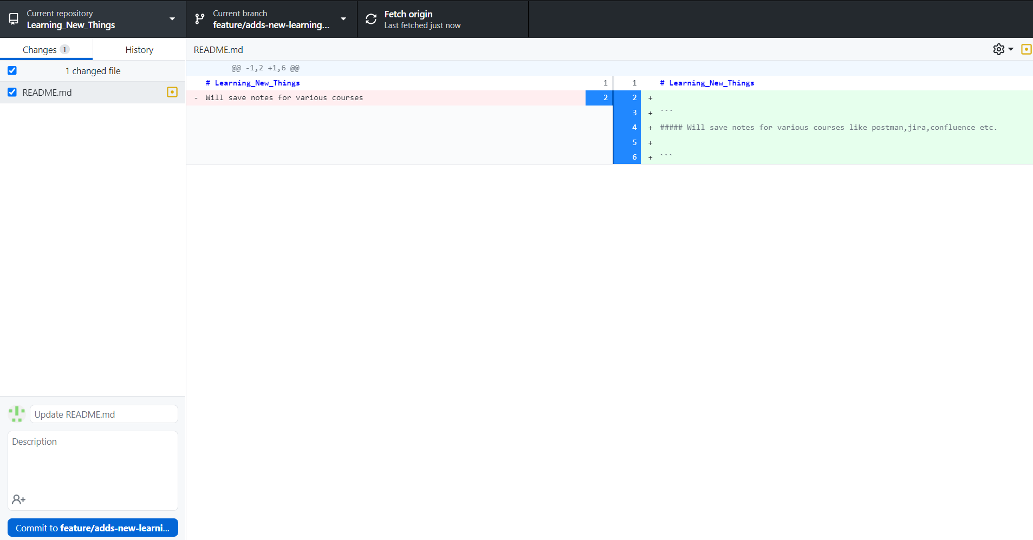

As u can see we modified readme.md file where we just added few of the lines n appended the previous comment.

In red color it shows what is removed n in green color it shows what is added.

You can see in changes field after the readme.md file we have yellow icon which indicates the file is modified,we get green icon if file is added newly n we get red icon if the file is deleted from the repo.







Let say we have some modification in a file where we added 5 new lines n let say instead of committing full file changes we can select which lines no should get committed as we don’t want the 5th line to be get committed how to do that is :

Just go to changes field n select the file then in middle panel u can see the changes so select which line u don’t want to commit for eg:5th line.thats it.!

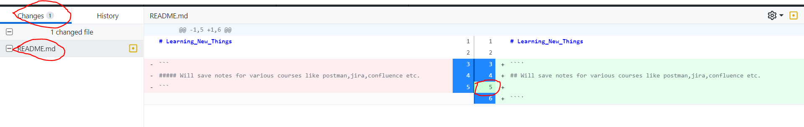

By above way, we can select n commit a partial file changes also.

Once we are ready to commit the change we have to provide the comment n description(optional) n then click on commit on <<branch name>> in bottom left corner.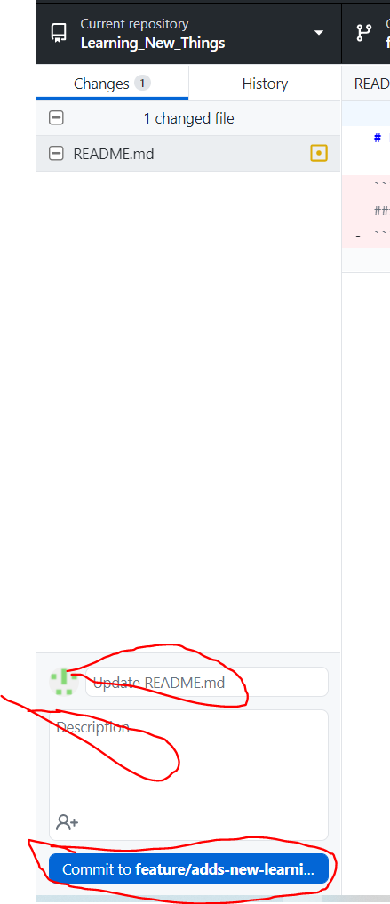

Once we commit the commit it in a local repo so to push this changes n commit to remote repo i.e github.com we need to click on push origin button

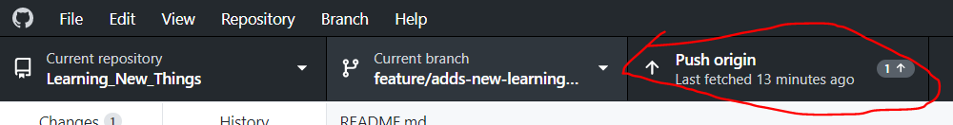

Before pushing you can undo the commit also if you don’t want to push those changes,by selecting undo the commit button below commit button in bottom left corner.

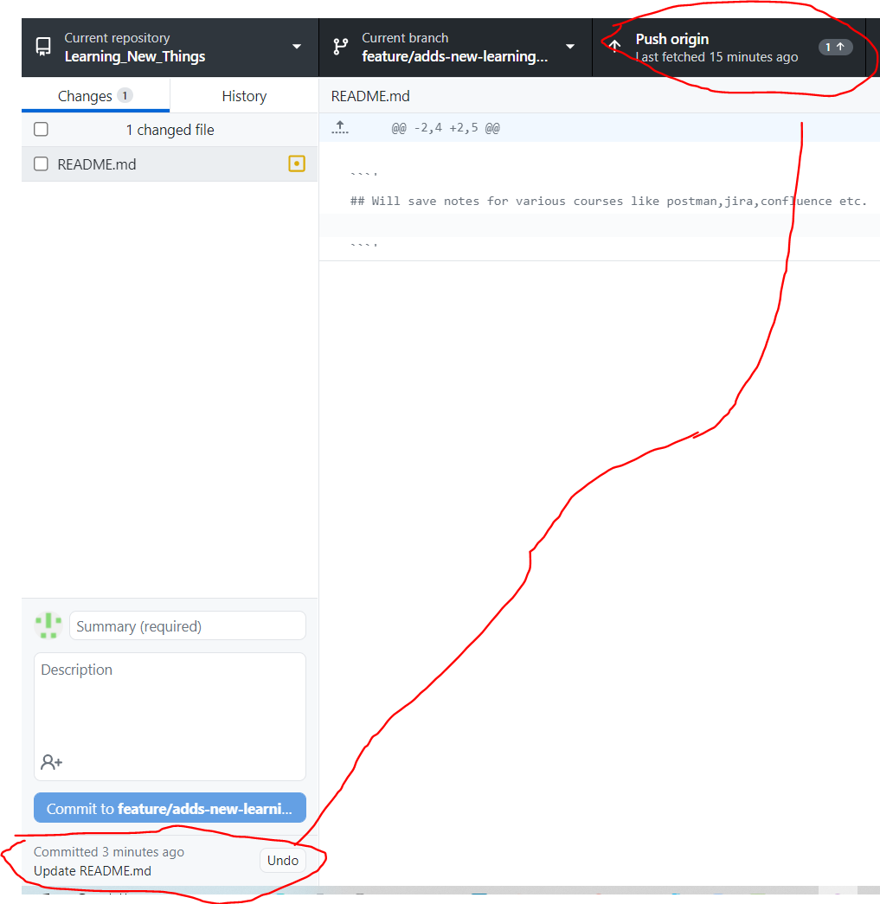

* Once we are done with creating new branch,pushing the branch,performing some changes,committing changes n then pushing back those changes to the branch ,Its time to create a pull request.

Pull Request is way of collaborating where we do the changes in diff branch n then we ask for review to others if they are satisfied with the changes then they can merge those changes in their branch.PR is like a request raising for a review n merging activity.

How to raise a PR?

1 way )

We can select current branch “master” becoz we want to merge into master so master should be selected in the tab in github desktop app n then we can choose Pull Requests tab

There we can see the list if not available we can create a new pull request by clicking on create a pull request link.It will redirect to github.com where we can add reviewer,label,assignee etc.

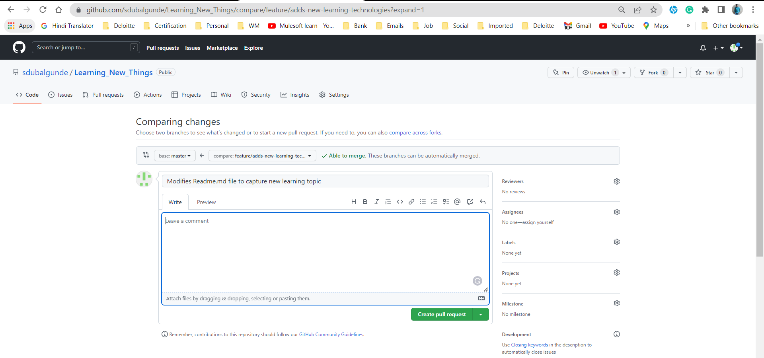

2nd way)

If we are done with pushing the changes to github.com then we can go to the remote repo select that repo,(if able to see compare n pull request button,click on that n it will present the same window like above img select base as master n compare as new branch{add reviewer,label n assignee n then click on create pull request button) n then go to pull request tab (if not able to see see compare n pull request button) press new pull request check the changes n select base as master n compare as new branch name{add reviewer,label n assignee n then click on create pull request button 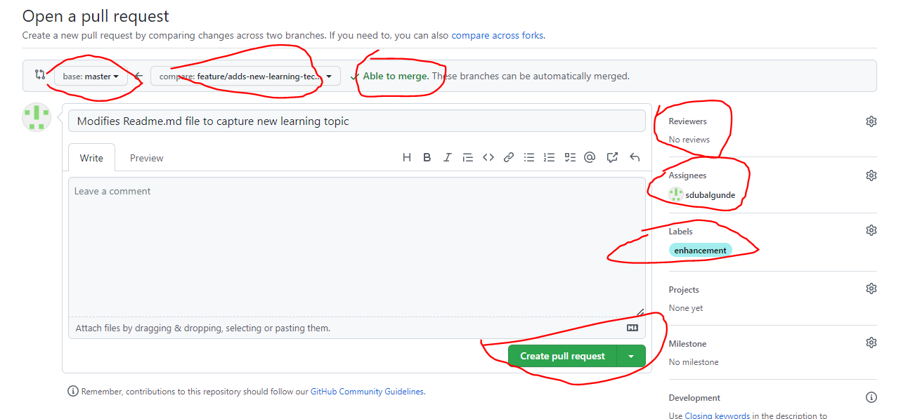

After clicking on create pull request button,If you have addedd any reviewer then it will wait for their review comment once done then if you have access or reviewer has access to merge they will merge the PR.

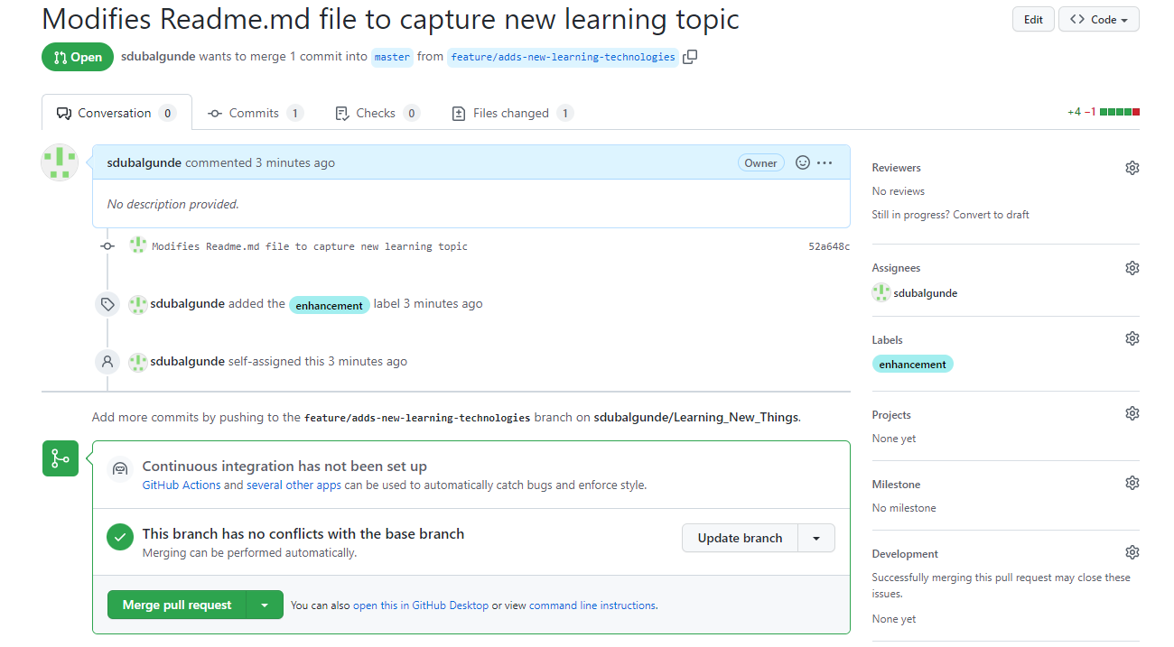

Merging the branch:

Once pull request is reviewed n ready to be merged then if you have access to merge or reviewer has access to merge then he will clikck on merge pull request.once clicked it will ask for comment that is already have in the comment we can modify it n then click on confirm merge. 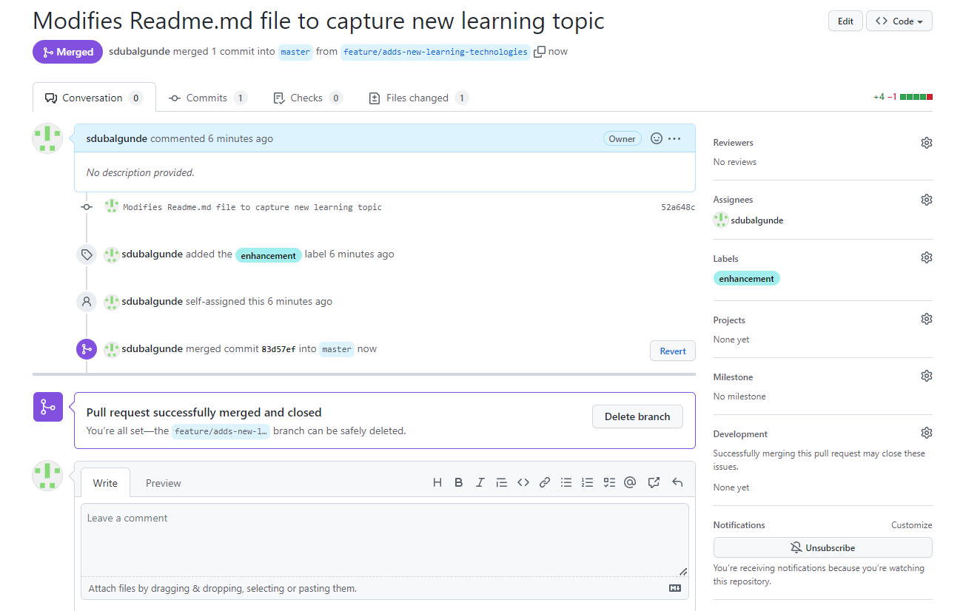

Affter merge is completed ,pull request will be closed n you can go to master branch to check whether you have latest code which is same as ur new branch.

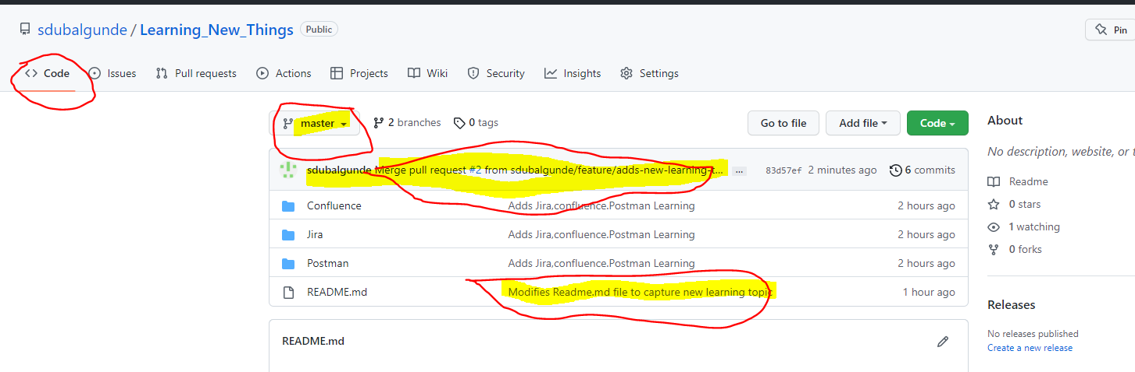

* How to create a project locally n then publishing it to GitHub.com?

Let say we are working on a project called ‘Demo_Project’ n for that we have created a folder inside our hard drive n we are using git as vcs so lets start

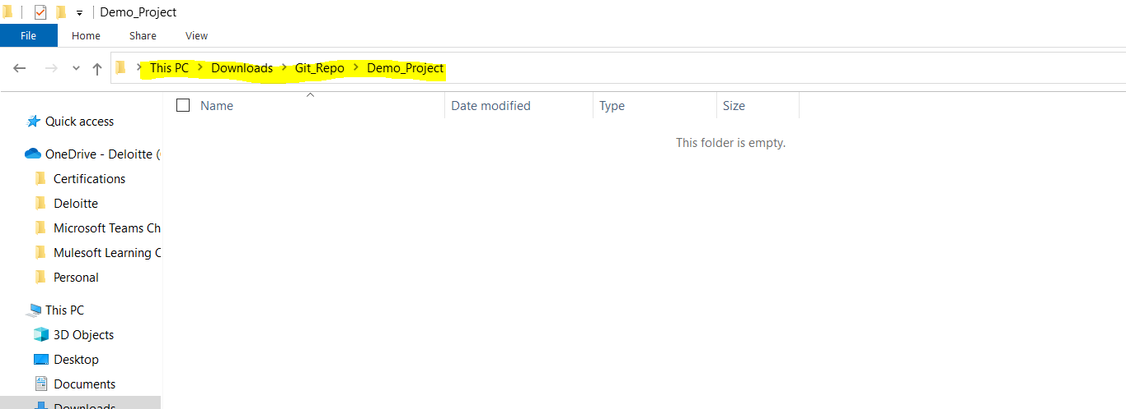

Open git bash inside Demo_project-> enter git init to initialize git n then type git status

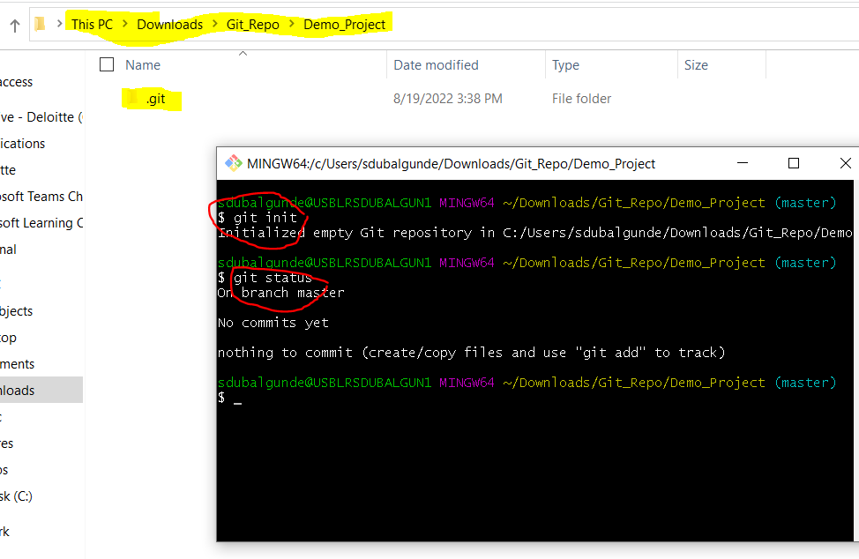

Now lets say we started working on the project n created,modified ,deleted files inside the Demo_Project. Then we ran below commands 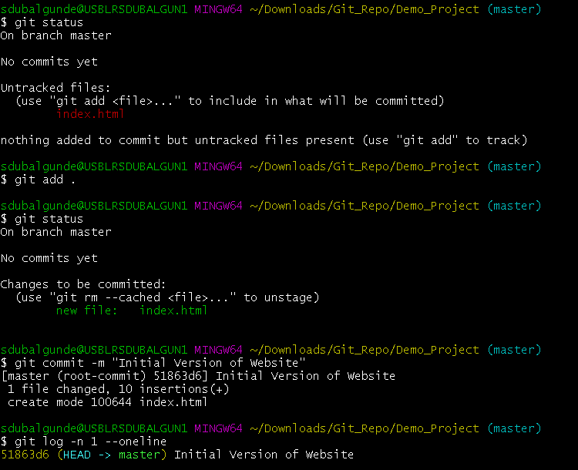

Once we commit the changes in local repo now lets start adding this local repo to remote repo by doing this commands:

 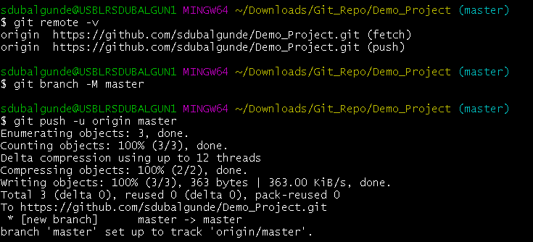

After performing above commands,the local changes will be available in github.com remote repository.

Note that whenever we do some changes in local repo so to see that changes in github.com we need to push our local changes to github otherwise changes wnt be visible in github.com

To get the changes done in github.com in local repo we need to use git pull command.